PhD thesis

Elías Sæbjörn Eyþórsson

2019-03-29

Table of Contents

# Introduction

Placeholder

## Clinical manifestations of *Streptococcus pneumoniae*

### Acute otitis media

#### Pathogens implicated in acute otitis media

#### Health care burden of otitis media

#### Tympanostomy tube procedures

#### Acute otitis media in Iceland

### Pneumonia

#### Pathogens causing pneumonia

#### Health care burden of pneumonia

### Invasive pneumococcal disease and mortality

## Pneumococcal vaccines

### A brief history of pneumococcal vaccination

### The impact of pneumococcal conjugate vaccines on otitis media

#### Randomized controlled trials evaluating the efficacy of pneumococcal conjugate vaccines for otitis media

#### Observational studies evaluating the impact of pneumococcal conjugate vaccines for otitis media.

### The impact of pneumococcal conjugate vaccines on pneumonia

### The impact of pneumococcal conjugate vaccines on invasive pneumococcal disease

## Cost-effectiveness in the context of pneumococcal conjugate vaccination

### Vaccine efficacy assumptions in economic analyses of pneumococcal conjugate vaccines

### Assumptions regarding costs and utilities in economic analyses of pneumococcal vaccines

# Aims

The aims of the thesis were to estimate the impact of PHiD-CV10 on

1. The incidence of pediatric emergency department visits for otitis media with treatment failure (Paper I)
2. The population-based incidence of otitis media visits in primary care (Papers II and VI)
3. The population-based herd-effect on otitis media among unvaccinated children (Papers II and VI)
4. The population-based incidence of outpatient antimicrobial prescriptions (Paper III)
5. The population-based incidence of tymapnostomy tube procedures (Paper IV)
6. The population-based incidence of hospitalizations for respiratory and invasive infections commonly associated with *Streptococcus pneumoniae* (Paper V)
7. The population-based herd-effect on pneumonia hospitalizations among unvaccinated children and adults (Paper VI)
8. The population-based herd-effect on hospitalizations for invasive pneumococcal disease among unvaccinated children and adults (Paper VI)
9. The cost-effectiveness of introducing PHiD-CV10 into the pediatric vaccination program in Iceland (Paper VI)

# Materials and methods

Placeholder

## Data collection and sources

### Statistics Iceland

### Landspitali University Hospital patient registry

### The Primary Care Registry

### The National Vaccine Registry

### The National Drug Prescription Registry

### Reimbursement database of Icelandic Health Insurance

## Impact on otitis media with treatment failure (Paper I)

## Impact on primary care visits for acute otitis media (Paper II)

## Impact on outpatient antimicrobial prescriptions (Paper III)

## Impact on tympanostomy tube procedures (Paper IV)

## Impact on respiratory associated hospitalizations (Paper V)

## Impact and cost-effectiveness analysis (Paper VI)

### Data sources

### Impact of PHiD-CV10

### Cost-effectiveness analysis

# Results

Placeholder

## Data collection and sources

### Statistics Iceland

### Landspitali University Hospital patient registry

### The Primary Care Registry

### The National Vaccine Registry

### The National Drug Prescription Registry

### Reimbursement database of Icelandic Health Insurance

## Impact on otitis media with treatment failure (Paper I)

## Impact on primary care visits for acute otitis media (Paper II)

## Impact on outpatient antimicrobial prescriptions (Paper III)

## Impact on tympanostomy tube procedures (Paper IV)

## Impact on respiratory associated hospitalizations (Paper V)

## Impact and cost-effectiveness analysis (Paper VI)

### Population impact on acute otitis media among children younger than 20 years of age

### Population impact on pneumonia hospitalizations

### Population impact on hospital admissions for invasive pneumococcal disease

# Discussion

Placeholder

## Main findings

## Data collection and sources (Papers I-VI)

## Epidemiology and management of otitis media in Iceland and the impact of PHiD-CV10 introduction (Papers I, II, III, V and VI)

### Epidemiology of acute otitis media in Iceland (Papers II and V)

### Impact on primary care visits for otitis media (Papers II and VI)

### Impact on pediatric emergency department visits for acute otitis media (Paper I)

### Impact on outpatient antimicrobial prescriptions for otitis media (Paper III)

### Evidence of herd-effect of PHiD-CV10 on the incidence of otitis media in the unvaccinated population (Papers II and VI)

### Impact on acute otitis media with treatment failure (Paper I)

### Impact of PHiD-CV10 on tympanostomy tube placements (Paper IV)

## Impact of PHiD-CV10 on hospital admissions for respiratory infections and invasive pneumococcal disease (Papers V and VI)

### Impact on hospital admissions for otitis media and its complications (Paper V)

### Impact on pediatric pneumonia hospitalizations (Papers V and VI)

### Impact on hospital admissions for culture confirmed invasive pneumococcal disease

### Evidence of herd-effect of PHiD-CV10 on pneumonia hospitalization in the unvaccinated population (Paper VI)

### Evidence of herd-effect of PHiD-CV10 on hospital admissions for invasive pneumococcal disease in the unvaccinated population (Paper VI)

## Cost-effectiveness of introducing PHiD-CV10 into the Icelandic pediatric vaccination program (Paper VI)

# Conclusions

Placeholder

## Direct and indirect impact on otitis media

## Direct impact on antimicrobial consumption

## Direct impact on tympanostomy tube placements

## Direct and indirect impact on pneumonia hospitalizations

## Direct and indirect impact on hospital admissions for invasive pneumococcal disease

## Cost-effectiveness of PHiD-CV10 intoduction

## Future research questions

### What is the relationship between the age of a child at the time of their first episode of acute otitis media and their future risk of recurrent or protracted disease?

### To what degree, if any, did physicians change their prescribing habits for AOM following the introduction of a universal pneumococcal vaccination program?

### What is the incidence of AOM with treatment failure and has it changed following vaccine introduction?

### What is the incidence and cumulative incidence of tonsillectomies in young children in Iceland?

### Do children experience fewer episodes of AOM after undergoing a tympanostomy tube placement than they would otherwise have experienced?

### Would tympanostomy tube procedures have increased to a larger degree, had PHiD-CV10 not been introduced into the pediatric vaccination program?

### What was the direct and indirect effect of PHiD-CV10 on individual and grouped serotypes of invasive pneumococcal disease, after adjustment for secular trends in both IPD and invasive disease caused by other pathogens?

## Conclusion

# Introduction

Pneumococcal conjugate vaccines (PCV) have been shown to provide direct protection against acute otitis media (AOM), pneumonia and invasive pneumococcal disease (IPD) among vaccinated individuals (Black et al. 2000; Cutts et al. 2005; Prymula et al. 2006; Tregnaghi et al. 2014). The introduction of PCV into national paediatric immunization programmes has consistently been associated with indirect protection against IPD (Shiri et al. 2017). Indirect protection against pneumonia has been established in several observational studies (Bruhn et al. 2017; Tsaban and Ben-Shimol 2017), while the indirect protection against AOM is less clear (Ben-Shimol et al. 2014; Sigurdsson et al. 2018).

A plethora of cost-effectiveness analyses of the inclusion of PCV in national immunization programmes have been published (Vooren et al. 2014), of which only two were conducted after the implementation PCV and incorporated the observed impact of the programme (Newall et al. 2016; Ray et al. 2009). All others were based on unmeasurable assumptions and their results heavily dependent on assumptions regarding indirect protection (Holubar et al. 2017).

In 2011, the 10-valent pneumococcal *Haemophilus influenzae* Protein D conjugate vaccine (PHiD-CV, Syn- florix) was included into the Icelandic paediatric immunization programme, with a two + one schedule given at three, five and 12 months of age. Children born in 2011 and later were eligible. Vaccine uptake was immediately high with over 97% of vaccine eligible children receiving the primary vaccination by their first birthday (Eythorsson et al. 2017).

The aim of the study was to evaluate the direct and indirect population impact of PHiD-CV10 introduction on AOM, pneumonia and IPD in Iceland, and to perform a post-implementation cost-effectiveness analysis using directly observed data.

# Methods

## Data sources

The study was population-based time series analysis. Data were obtained from the Primary Care Registry of the Icelandic Directorate of Health, and Landspítali University Hospital’s patient registry. The Primary Care Registry of the Icelandic Directorate of Health contains information on all primary care visits within the Icelandic healthcare system. Visits associated with International Classification of Diseases, 10th revision (ICD-10) diagnostic codes compatible with otitis media (H65, H66, H70, H72) were extracted from the Primary Care Registry. Visits associated with subchapters of the ICD-10 diagnostic coding system were extracted as synthetic controls (Table 1). The observation period was restricted to 2005-2015, as the Primary Care Registry was not updated for 2016 and 2017.

Data regarding hospitalized pneumonia and IPD were obtained from Landspitali University Hospital’s patient registry for the period 2005-2017. Hospitalized pneumonia was defined as any hospital admission associated with ICD-10 diagnostic codes J12-J18. Hospitalized IPD was defined based on microbiological data. Data were extracted from a database maintained by the Department of Clinical Microbiology at Landspitali University Hospital and linked to the patient registry. Hospitalized IPD was defined as any hospital admission associated with culture or PCR-confirmed *Streptococcus pneumoniae* sampled from joint fluid, bone, cerebrospinal fluid or blood, regardless of ICD-10 discharge diagnosis. Hospitalizations associated with subchapters of the ICD-10 diagnostic coding system were extracted as synthetic controls (Table 1).

Table 1 The International Classification of Diseases, 10th revision subchapters used to define the synthetic controls used in time series analyses.

|  |  |
| --- | --- |
| ICD-10 code | Description |
| A10-B99 | Certain infectious and parasitic diseases |
| C00-D48 | Neoplasms |
| D50-89 | Diseases of the blood and blood-forming organs and certain disorders involving the immune mechanism |
| E00-99 | Endocrine, nutritional and metabolic diseases |
| G00-G99 | Diseases of the nervous system |
| H00-99 | Diseases of the eye and adnexa, Diseases of the ear and mastoid process |
| I00-99 | Diseases of the circulatory system |
| K00-99 | Diseases of the digestive system |
| L00-99 | Diseases of the skin and subcutaneous tissue |
| M00-99 | Diseases of the musculoskeletal system and connective tissue |
| N00-99 | Diseases of the genitourinary system |
| P00-99 | Certain conditions originating in the perinatal period |
| Q00-99 | Congenital malformations, deformations and chromosomal abnormalities |
| R00-99 | Symptoms, signs and abnormal clinical and laboratory findings, not elsewhere classified |
| S00-T99 | Provisional assignment of new diseases of uncertain etiology |
| U00-99 | Injury, poisoning and certain other consequences of external causes |
| V00-Y99 | External causes of morbidity |
| Z00-99 | Factors influencing health status and contact with health services |

For each hospitalization or emergency department visit, a detailed breakdown of cost was available, which was extracted for each of the disease categories included in the study. No cost data was available for primary care visits. Because Children’s Hospital Iceland’s paediatric emergency department serves as a walk-in clinic for the greater capital area, the distribution of costs for otitis media visits to the emergency department was assumed to mirror that of primary care visits, and was used in its stead. The number of PHiD-CV10 doses purchased by the government and the unit price for each dose per calendar year were obtained directly from the Icelandic Directorate of Health. The yearly employment rate of individuals 15 to 24 years of age, 25 to 54 years of age and 55 to 64 years of age from 2011-2017 was extracted from Organization for Economic Cooperation and Development (OECD) Labour Force Statistics (*OECD Labour Force Statistics* 2018), and the deciles of regular total wage for working Icelanders from 2011-2017 were obtained from Statistics Iceland. The consumer price index for medical care obtained from Statistics Iceland was used to convert all direct health care costs to 2015 price levels in Icelandic kronas. All costs were converted to United States Dollars (USD) using the offical exchange rates of the Icelandic Central Bank.

## Impact of PHiD-CV10

The impact of PHiD-CV10 introduction on the incidence of pneumococcal disease was estimated and the results then used as an input for a cost-effectiveness analysis. This was accomplished using a previously published Bayesian time series methodology (Bruhn et al. 2017; Shioda et al. 2018). The pre-vaccine period was defined as 1 January 2005 to 31 December 2010, and the post-vaccine period as 1 January 2013 to 31 December 2017. A transition period was included from 2011 to 2012. For each disease category and age-group, four models of PHiD-CV10 impact were estimated. All were Bayesian Poisson models with observation specific random intercepts to account for over-dispersion (Dvorzak and Wagner 2019). Each model utilized the pre-vaccine period to predict the monthly occurrence of the outcome of interest in the post-vaccine period, had the vaccination not occurred. These models were then combined using a Bayesian model-stacking procedure. The methods are described in more detail in the supplementary appendix.

From the posterior predictive distribution of the stacked model, a total of 10,000 Markov chain Monte Carlo (MCMC) samples were drawn, representing the number of cases that would have occurred in the post-vaccine period, had the vaccine not been introduced. The first 2,000 MCMC draws were discarded for optimal burn-in. For each of the remaining 8,000 draws, the rate ratio between the observed and predicted number of cases during the post-vaccine period was calculated, and the median and 95% credible intervals extracted from the resulting distribution of rate ratios. To estimate the onset of vaccine impact, the rate ratio was calculated over a rolling 12-month period, the first of which included 11-months of pre-vaccine data and one month of post-vaccine data. The number of cases prevented by the vaccine was caclulated for each calendar-month, by subtracting the observed number of cases from each of the 8,000 MCMC draws. The cumulative sum of prevented cases was calculated, and the median and 95% credible intervals were extracted.

## Cost-effectiveness analysis

The cost-effectiveness of PHiD-CV10 introduction compared to no intervention was estimated from both the healtcare and societal perspectives using ecological post-implementation data. The societal perspective included both direct costs and indirect costs associated with productivity loss, while analysis from the health care perspective included only direct costs. Neither analysis included estimates of long-term sequelae or their associated costs. The time horizon was five years and both costs and cost-savings were discounted at a 3% discount rate. All costs were presented in constant 2015 USD. A summary of the cost-effectiveness parameters and assumptions are presented in Table 2.

Table 2 A summary of the parameters and assumptions of the cost-effectiveness analysis

|  |  |
| --- | --- |
| Parameter | Description |
| Perspective | Healthcare, Societal |
| Comparators | PHiD-CV10 vs no vaccine |
| Model | Ecological time series |
| Time horizon | 5 years |
| Price date | 2015 |
| Discount rate | 3% |
| Costs | Directly observed with resampling |
| Vaccine uptake | Implicitly included |
| Vaccine coverage | Implicitly included |
| Serotype replacement | Implicitly included |
| Herd-effect | Implicitly included |

The direct cumulative savings associated with PHiD-CV10 introduction were calculated by multiplying the predicted number of prevented cases from the Bayesian time series analysis with the expected cost of each case. The expected cost was obtained through sampling with replacement from the observed costs extracted from Landspitali University Hospital’s patient registry. The sampling was stratified by disease category and age-group. The direct costs associated with the introduction of PHiD-CV10 into the paediatric immunization programme were calculated for each calendar-year by multiplying the number of purchased doses by the price of each purchased dose. Wastage was taken into account, as this formula included doses that were for whatever reason never administered. Additional administration costs were however not assumed, as each dose was administered by nurses during the same visits that other establised vaccines were being given. The direct costs associated with the vaccine were subtracted from the direct cumulative savings to obtain the final estimate of the total cost. This resulted in 8,000 posterior draws of the total cost, from which the median and 95% credible intervals were extracted.

Indirect costs due to productivity loss were accounted for in the analysis from the societal perspective. The deciles of wage that were extracted from Statistics Iceland were optimally fitted to a lognormal distribution to obtain a continuous distribution of wage (Belgorodski et al. 2017). The number of days of work lost were assumed. For each case of otitis media in primary care, the days of work lost by a parent or guardian were assumed to follow a Poisson distribution with mean equalling one. For each pneumonia or invasive pneumococcal disease hospitalization, the days of work lost were assumed to equal the sum of the hospital length of stay and a variable time following discharge. For each prevented case, the associated hospital length of stay was sampled with replacement from the observed length of stay obtained from the patient registry. This variable time was assumed to be Poisson distributed with mean equal to half the observed hospital length of stay. The indirect costs were calculated by multiplying the days of work lost with wages sampled from the lognormal wage distribution, accounting for unemployment. Cost-effectiveness was summarized with incremental cost-effectiveness ratios (ICER) with 95% credible intervals.

## Sensitivity analysis

Sensitivity analyses were conducted for both the PHiD-CV10 impact models and the cost-effectiveness analysis. Four sensitivity analyses were performed to validate the robustness of the impact models.

Firstly, the sensitivity of the impact models to the choice of pre-vaccine period was evaluated by iteratively choosing three year pre-vaccine periods (2005-2007, 2006-2008, 2007-2009, and 2008-2010) and refitting the models for each disease category and age-group. Secondly, the robustness of the synthetic control models with regards to the included covariates was evaluated by removing the top covariate and re-estimating the rate ratio. This was done iteratively three times and the resulting three rate ratios were compared to the one obtained in the main analysis. Thirdly, several different case-definitions for each disease category were explored in seperate sensitivity analyses. The models were refitted with two additional definitions of otitis media (visits with ICD-10 code H66 only, and visits with ICD-10 codes H65, H66, H70, H72, associated with a filled antimicrobial prescription), and two additional definitions of pneumonia (hospitalizations with ICD-10 codes J13, J15.8, J15.9, J18.1, J18.8 and J18.9; and hospitalizations with ICD-10 codes J13, J15.8, J15.9, J18.1, J18.8 and J18.9 in which microbiological and radiological examinations had been performed). The impact of PHiD-CV10 on vaccine-type IPD was also evaluated. Finally, the models were re-fitted with urinary tract infections as the outcome variable to evaluate the specificity of the results with regard to infections likely to be caused by pneumococcus.

The Bayesian approach used to estimate the cost-effectiveness produces a posterior predictive distribution that includes the uncertainty associated with the input parameters. The observed cost of the vaccine was

# Results

### Population impact on acute otitis media among children younger than 20 years of age

From 1 January 2005 to 31 December 2015, children younger than 20 years of age visited primary care physicians 164,453 times for AOM and its complications. The monthly number of AOM visits during the post-vaccine period was lower than average in all age-groups. Overall visits also decreased during the post-vaccine period, but the degree by which visits for AOM decreased was larger in magnitude (Supplementary Figure 1).

The posterior predicted AOM visits and 95% credible intervals are are shown in Figure 1. With few exceptions, the observed number of AOM visits are fewer than predicted in the post-vaccine period, indicating that the vaccine prevented visits from occurring. The posterior predictions of each component model are shown in Supplementary Figure 2, and the weights used to produce the final stacked model are presented in Supplementary Table 1.

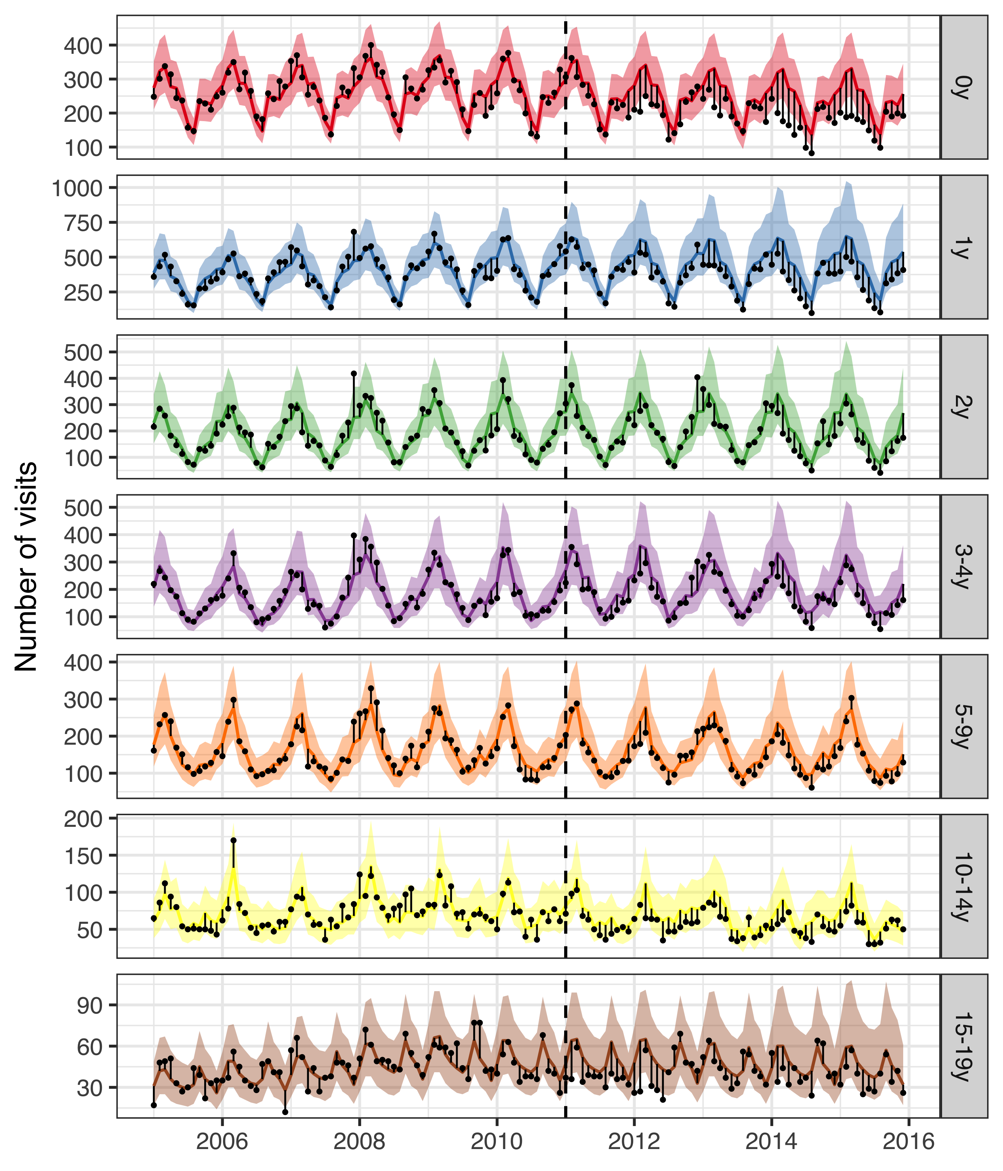

Figure 1 The observed and predicted number of AOM visits from 1 January 2005 to 31 December 2015 for each age-group. Observed visits are illustrated as black points, the posterior predicted visits are presented as lines and 95% credible intervals as a shaded area. The start of the vaccine period is delineated with a vertical black dotted line. The distance between the observed and predicted visits for each calendar-month is depicted with a thin black line. Assuming that the model is correct and that no intervention had taken place, the black points would have an equal probability of occurring above and below the prediction line. Points below the lower bound of the shaded area would then represent observations that would have had less than a 2.5% probability of occurring. Given that the majority of points are located below the prediction line, and many located below the lower bound of the shaded area, the figure suggests that the vaccine resulted in fewer AOM visits. Note that the scale of the Y-axis differ between age-groups.

The 95% credible interval of the rate ratio between the observed and predicted number of AOM visits was lower than one in all age-groups, indicating that there was a 97.5% or greater probability that the rate of AOM decreased due to the introduction of PHiD-CV10 in all age-groups (Table 3). The decrease was largest among young children; 16% (12%-36%) in children younger than one year of age and 18% (5%-42%) in children one year of age. A 12-month rolling rate ratio between the observed and predicted number of AOM cases is presented in Panel A of Figure 2. Visually, the rate of AOM cases among children younger than one seems to begin to decline in January 2012, and cases among children one year of age seems to decline in July 2012.

Table 3 The rate ratio between observed and predicted number of primary care visits due acute otitis media and complications (AOM) during the post-vaccine period (2013-2015), is presented with 95% credible intervals (95% CI) for the seven age-groups included in the study. The predicted cumulative number of prevented cases as of 1 December 2015 is also presented. A negative number indicates that there is a non-zero probability that the vaccine caused more AOM visits to occur. Direct and indirect savings are presented in 2015 USD.

|  |  |  |  |  |
| --- | --- | --- | --- | --- |
| Age-group | Rate ratio (95% CI) | Cumulative cases prevented (95% CI) | Direct savings (95% CI) | Indirect savings (95% CI) |
| 0y | 0.74 (0.64-0.88) | 3,234 (1,008 to 5,195) | 305,330$ (90,933$ to 514,848$) | 45,386$ (11,143$ to 84,654$) |
| 1y | 0.72 (0.58-0.95) | 5,802 (817 to 11,526) | 530,468$ (57,564$ to 1,150,759$) | 74,298$ (3,778$ to 193,180$) |
| 2y | 0.88 (0.66-0.98) | 900 (-185 to 3,817) | 92,117$ (-52,649$ to 407,227$) | 14,377$ (-11,004$ to 64,562$) |
| 3-4y | 0.86 (0.69-0.97) | 1,702 (21 to 3,576) | 135,274$ (-16,985$ to 357,905$) | 23,880$ (-4,324$ to 62,811$) |
| 5-9y | 0.88 (0.73-0.96) | 979 (229 to 2,521) | 134,548$ (-38,612$ to 430,729$) | 14,242$ (-1,030$ to 40,961$) |
| 10-14y | 0.83 (0.75-0.92) | 720 (411 to 1,086) | 113,333$ (4,669$ to 285,816$) | 10,313$ (-3,098$ to 20,035$) |
| 15-19y | 0.89 (0.56-0.98) | 430 (210 to 1,689) | 55,819$ (-8,278$ to 227,493$ | 6,169$ (698$ to 25,248$) |

The cumulative number of prevented AOM cases reflect both the rate of AOM cases in each age-group, and the consistency and magnitude of the vaccine effect. The cumulative prevented cases per age-group as of December 2015 are presented in Table 3. The largest effects are seen in the youngest age-groups, who both had the highest baseline rates and experienced the largest relative declines following vaccine introduction. The cumulative number of prevented cases as a function of time during the post-vaccine period is shown in Panel B of Figure 2.

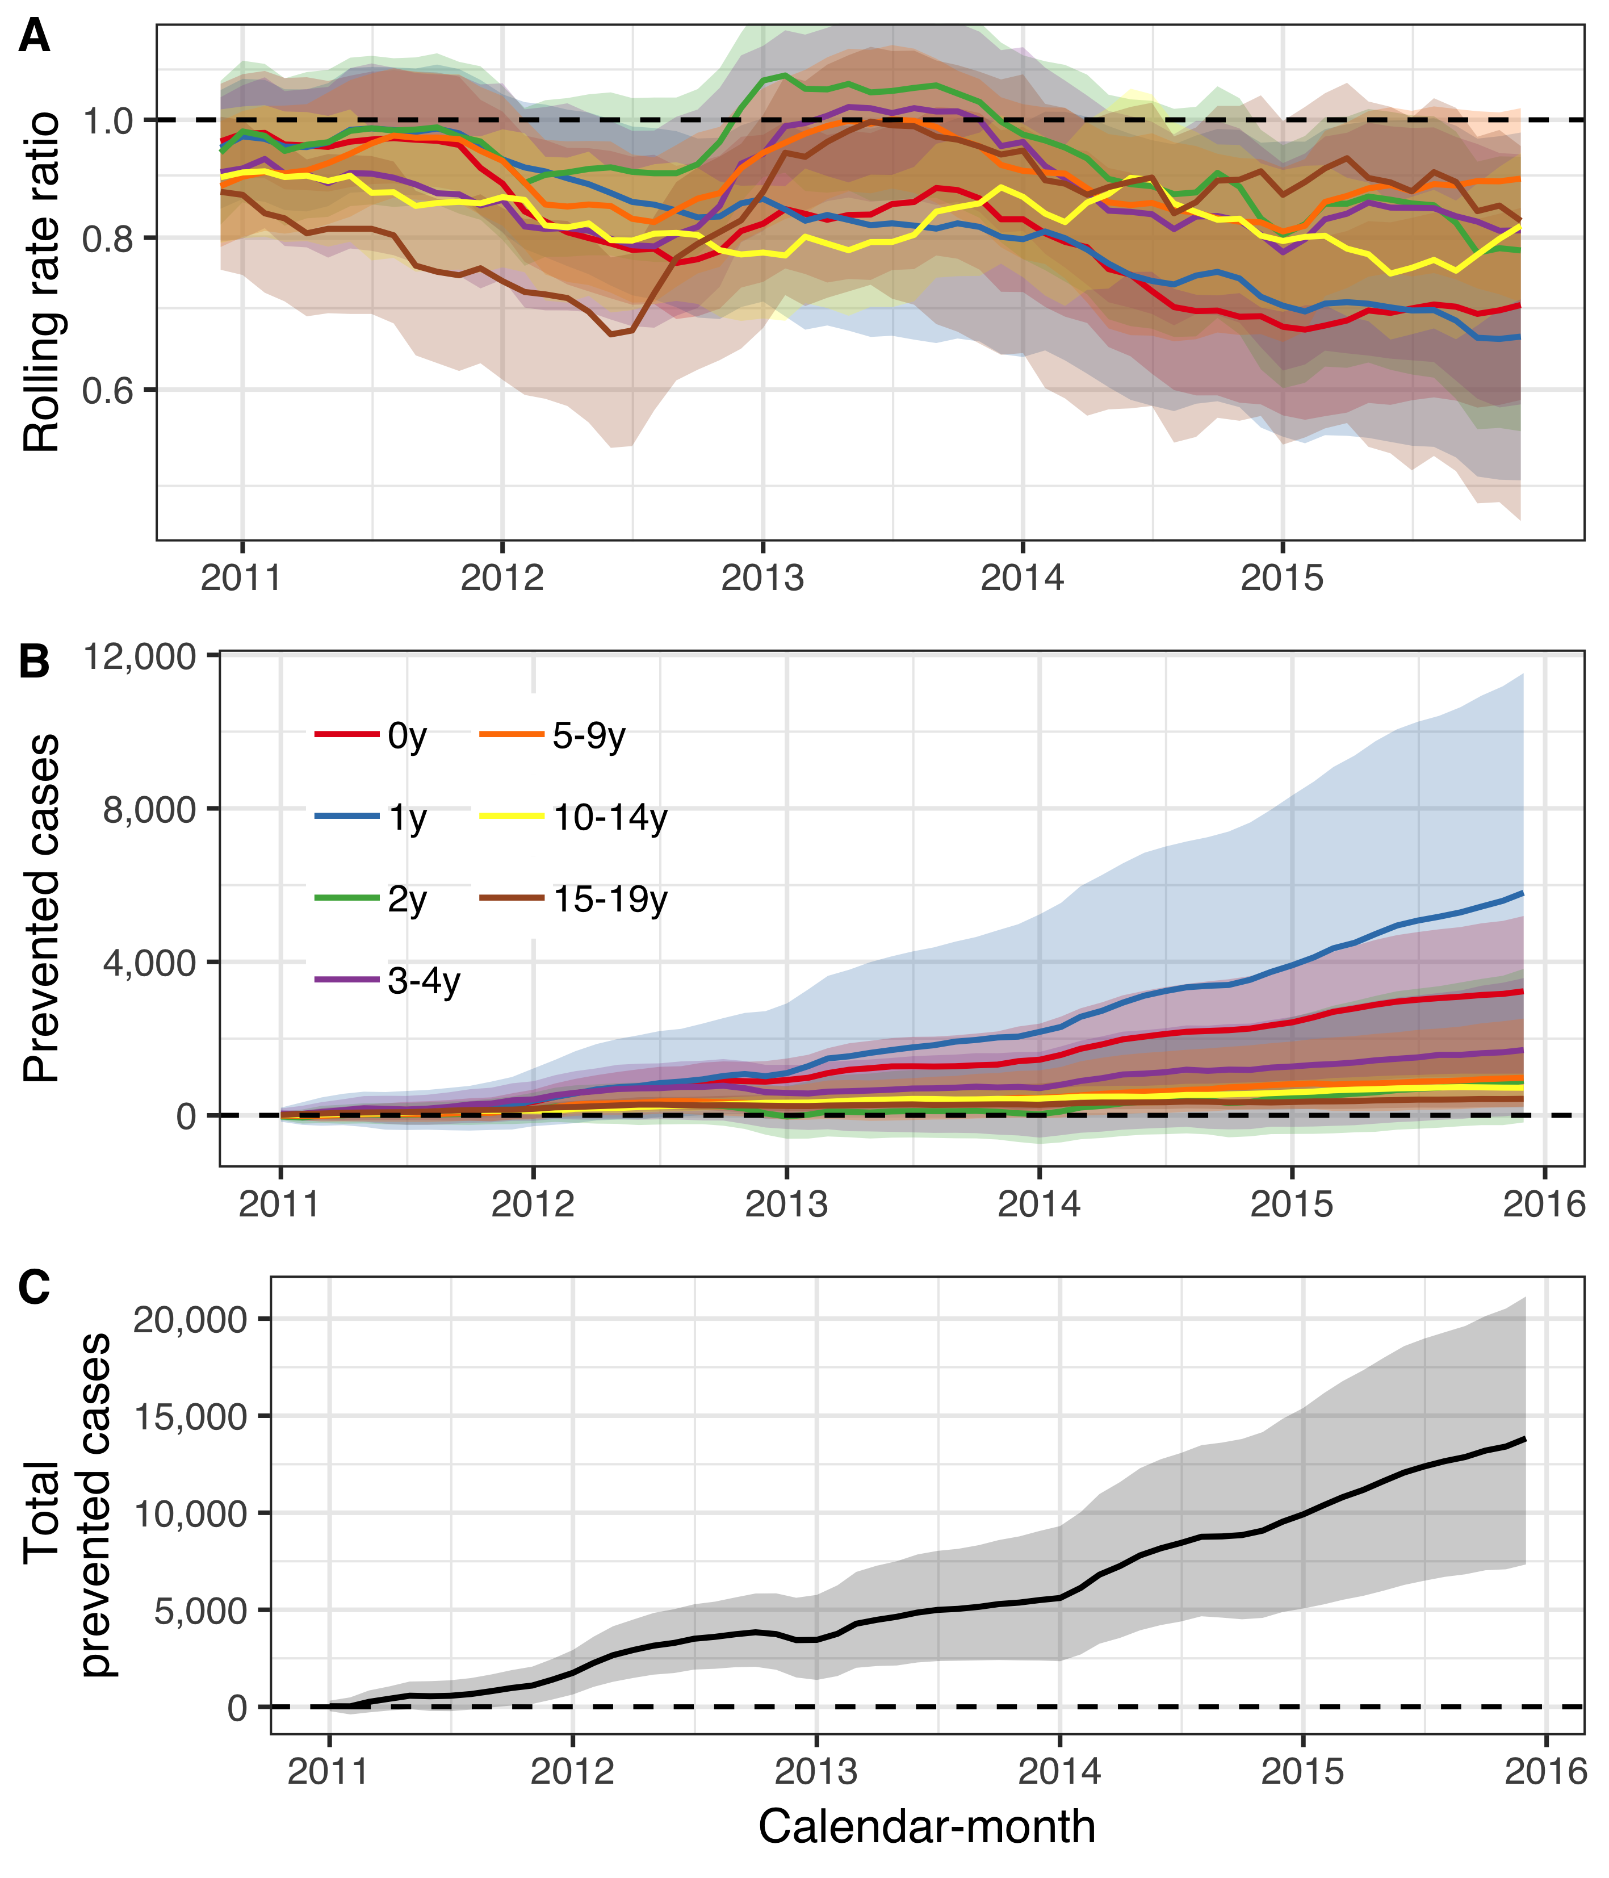

Figure 2 The impact of the 10-valent *Haemophilus influenzae* protein D pneumococcal conjugate vaccine (PHiD-CV10) on acute otitis media and complications (AOM) among children younger than 20 years of age is summarized. In Panel A, the estimated 12-month rolling rate ratio between observed and predicted AOM cases is shown per age-group, and the 95% credible intervals (CI) are illustrated as a shaded area. Panel B depicts the cumulative number of prevented AOM cases during the post-vaccine period (2011-2015) for each age-group, along with 95% CI. The total cumulative prevented AOM cases regardless of age-group is shown in Panel C.

Sensitivity analyses did not reveal important inconstistencies regarding the underlying modeling assumptions (Supplementary appendix).

### Population impact on pneumonia hospitalizations

From 1 January 2005 to 31 December 2017, 13,373 hospitalizations for pneumonia were recorded. Monthly pneumonia hospitalizations displayed complex trends over the study period. Pneumonia hospitalizations increased fairly rapidly during the pre-vaccine period among adults 40 years and older, and subsequently decreased at variable times in the post-vaccine period. Similarly, hospitalizations regardless of diagnosis increased among adults 20 years and older during the pre-vaccine period (Supplementary Figure 3).

The predicted number of cases and 95% credible intervals are are shown in Figure 3. During most of the post-vaccine period, the observed number of hospitalizations were equal to or below the prediction line among children zero to four years of age, and among adults 20 to 39, 65-79 and 80 years of age and older. The posterior predictions of the component models are shown in Supplementary Figure 4 and the weights used to produce the final stacked model are presented in Supplementary Table 1.

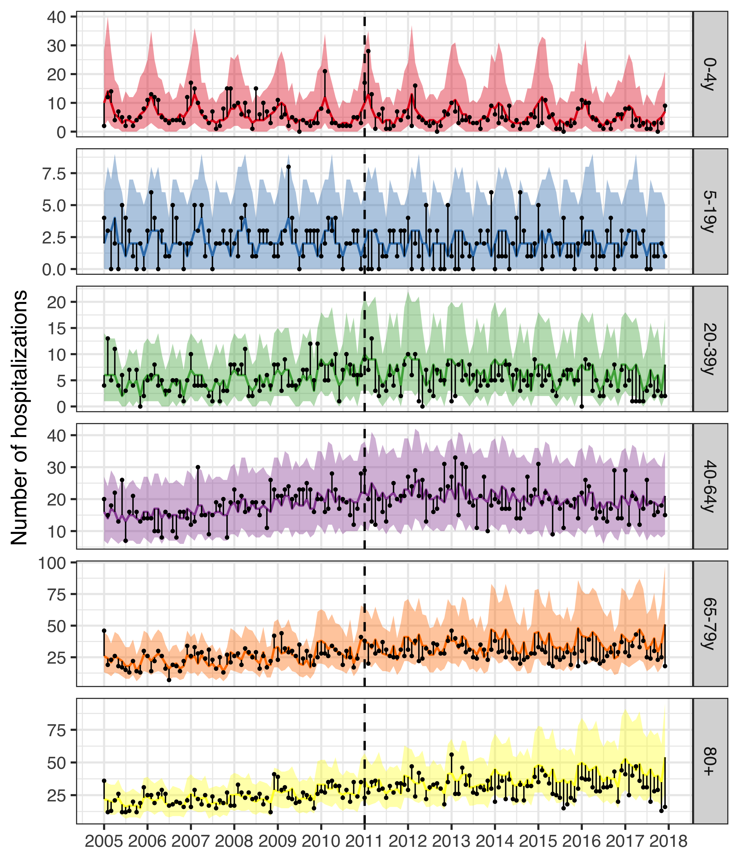

Figure 3 The observed and predicted number of pneumonia hospitalizations from 1 January 2005 to 31 December 2017 for each age-group. Observed cases are illustrated as black points. The predicted number of hospitalizations are presented as lines and 95% credible intervals as a shaded area. The start of the vaccine period is delineated with a vertical black dotted line. The distance between the observed and predicted cases for each calendar-month is depicted with a thin black line. Assuming that the model is correct and that no intervention had occurred, the black points would have an equal probability of appearing above and below the prediction line. Given that the majority of points are located below the prediction line, the figure suggests that the vaccine resulted in fewer pneumonia hospitalizations. Note that the scale of the Y-axis differ between age-groups.

The rate ratios between the observed and predicted number of pneumonia hospitalizations are shown in Table 4. Among children zero to four years of age, the posterior median of the rate ratio was 0.67, and the 2.5% credidble limit was 0.51. This was consistent with a 2.5% probability that the rate ratio was lower than 0.51 and a 47.5% probability that the rate ratio layed between 0.51 and 0.67. Though the 97.5% credible limit was above the threshold value of one, there was a 94% probability that the rate ratio was lower than one, and a 90% probability that it was lower than 0.83. Simlarly the posterior median of the rate ratio was 0.74 among children five to 19 years of age, and there was a 90% probability that the rate ratio was lower than one. Among adults 65 to 79 years of age, and 80 years of age and older, the posterior median of the rate ratio was 0.75 and 0.76 respectively, and both had a 97% probability of being lower than one.

A 12-month rolling rate ratio between the observed and predicted number pneumonia hospitalizations is presented in Panel A of Figure 4. Visually, the rate of pneumonia hospitalizations among children zero to four years of age seems to begin to decline in January 2012 (the first rolling 12-month period to include only post-vaccine months), and hospitalizations among adults 65 years of age and older seems to begin to decline in January 2014.

Table 4 The posterior median of the rate ratio between observed and predicted number pneumonia hospitalizations during the post-vaccine period (2013-2017) is presented with 95% credible intervals (95% CI) for the six age-groups included in the study. The predicted cumulative number of prevented cases as of 1 December 2017 is also presented. A negative number indicates that there is a non-zero probability that the vaccine caused more pneumonia hospitalizations to occur. Direct and indirect savings are presented in 2015 USD.

|  |  |  |  |  |
| --- | --- | --- | --- | --- |
| Age-group | Rate ratio (95% CI) | Cumulative cases prevented (95% CI) | Direct savings (95% CI) | Indirect savings (95% CI) |
| 0-4y | 0.67 (0.51-1.39) | 142 (-115 to 307) | 444,533$ (-44,181$ to 1,309,917$) | 52,535$ (-59,043$ to 136,715$) |
| 5-19y | 0.74 (0.54-1.35) | 52 (-27 to 113) | 234,848$ (-236,236$ to 748,522$) | 20,472$ (-18,876$ to 61,481$) |
| 20-39y | 0.68 (0.51-0.95) | 182 (14 to 384) | 968,662$ (-203,048$ to 2,567,059$) | 70,071$ (-9,442$ to 164,747$) |
| 40-64y | 0.92 (0.79-1.22) | 141 (-270 to 445) | 933,290$ (-2,748,49$ to 4,848,557$) | 71,953$ (-113,414$ to 223,171$) |
| 65-79y | 0.75 (0.55-1.02) | 666 (-49 to 1,648) | 5,476,585$ (-910,021$ to 15,590,280$) | 323,964$ (-4,745$ to 786,252$) |
| 80+ | 0.76 (0.56-1.02) | 631 (-76 to 1,615) | 4,664,256$ (-817,266$ to 13,013,699$) | 287,270$ (-37,961$ to 742,168$) |

The cumulative prevented pneumonia hospitalizations per age-group as of December 2017 are presented in Table 4. The largest effects were seen in adults 65 years of age and older, which reflects the baseline number of cases. The predicted cumulative number of prevented hospitalizations as a function of time during the post-vaccine period is shown in Panel B of Figure 4.

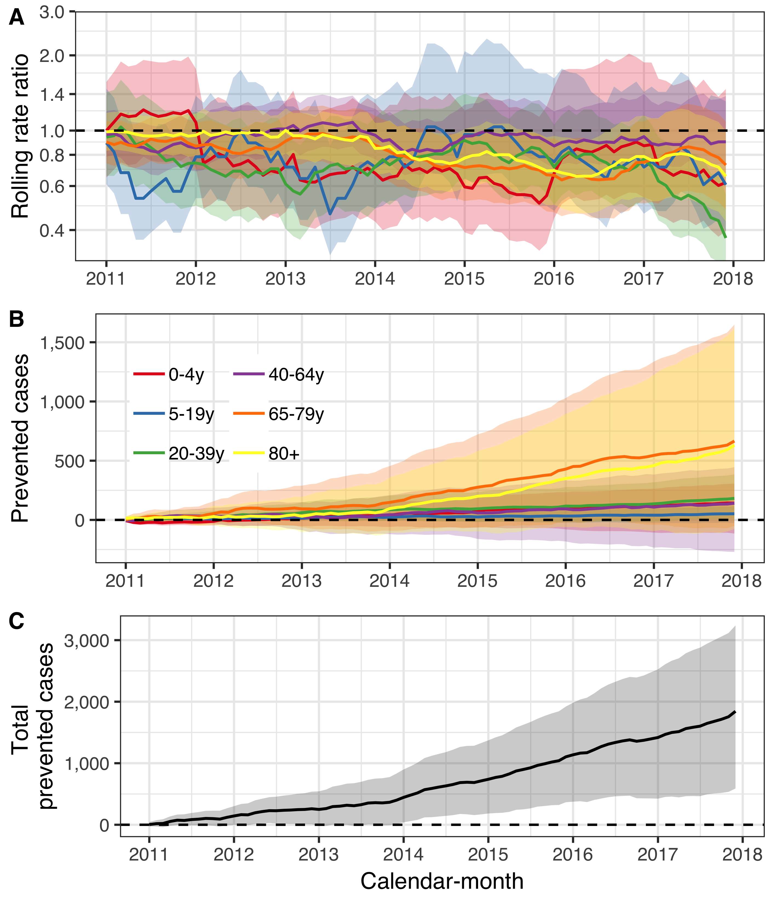

Figure 4 The population impact of the 10-valent *Haemophilus influenzae* protein D pneumococcal conjugate vaccine (PHiD-CV10) on pneumonia hospitalizations is summarized. In Panel A, the estimated 12-month rolling rate ratio between observed and predicted pneumonia hospitalizations is shown per age-group, and the 95% credible intervals (CI) are illustrated as a shaded area. Panel B depicts the cumulative number of prevented pneumonia hospitalizations during the post-vaccine period (2011-2017) for each age-group along with 95% CI. The total cumulative prevented pneumonia hospitalizations regardless of age-group is shown in Panel C.

### Population impact on hospital admissions for invasive pneumococcal disease

From 1 January 2005 to 31 December 2016, 338 hospitalizations for culture confirmed invasive pneumococcal disease were recorded. Of those, 206 occurred before the introduction of PHiD-CV10 into the paediatric immunization programme in Iceland. Standardized hospitalizations for IPD decreased among children zero to four years of age, while standardized hospital admissions regardless of cause did not decrease to the same extent (Supplementary Figure 5). Discrepancies between hospital admissions for IPD and all-cause hospitalizations were also noted in the other age-groups. Hospitalizations for IPD among individuals five to 64 years of age decreased while all-cause hospitalizations remained stable. While hospital admissions for IPD among adults 65 years of age and older did not change visibly, the standardized all-cause hospitalizations increased, suggesting a relative decline in IPD admissions (Supplementary Figure 5).

The posterior prediction of IPD hospitalizations and 95% credible intervals are are shown in Figure 5. Among children zero to four years of age, observed IPD hospitalizations were equal to or fewer than the predicted hospitalizations in all but two quarters. Similary, observed hospitalizations among indvidiuals five to 64 years of age were fewer than predicted more often than expected. Both suggest that the vaccine prevented cases from occurring. The posterior predictions of the component models are shown in Supplementary Figure 5 and the stacking weights are shown in Supplementary Table 1.

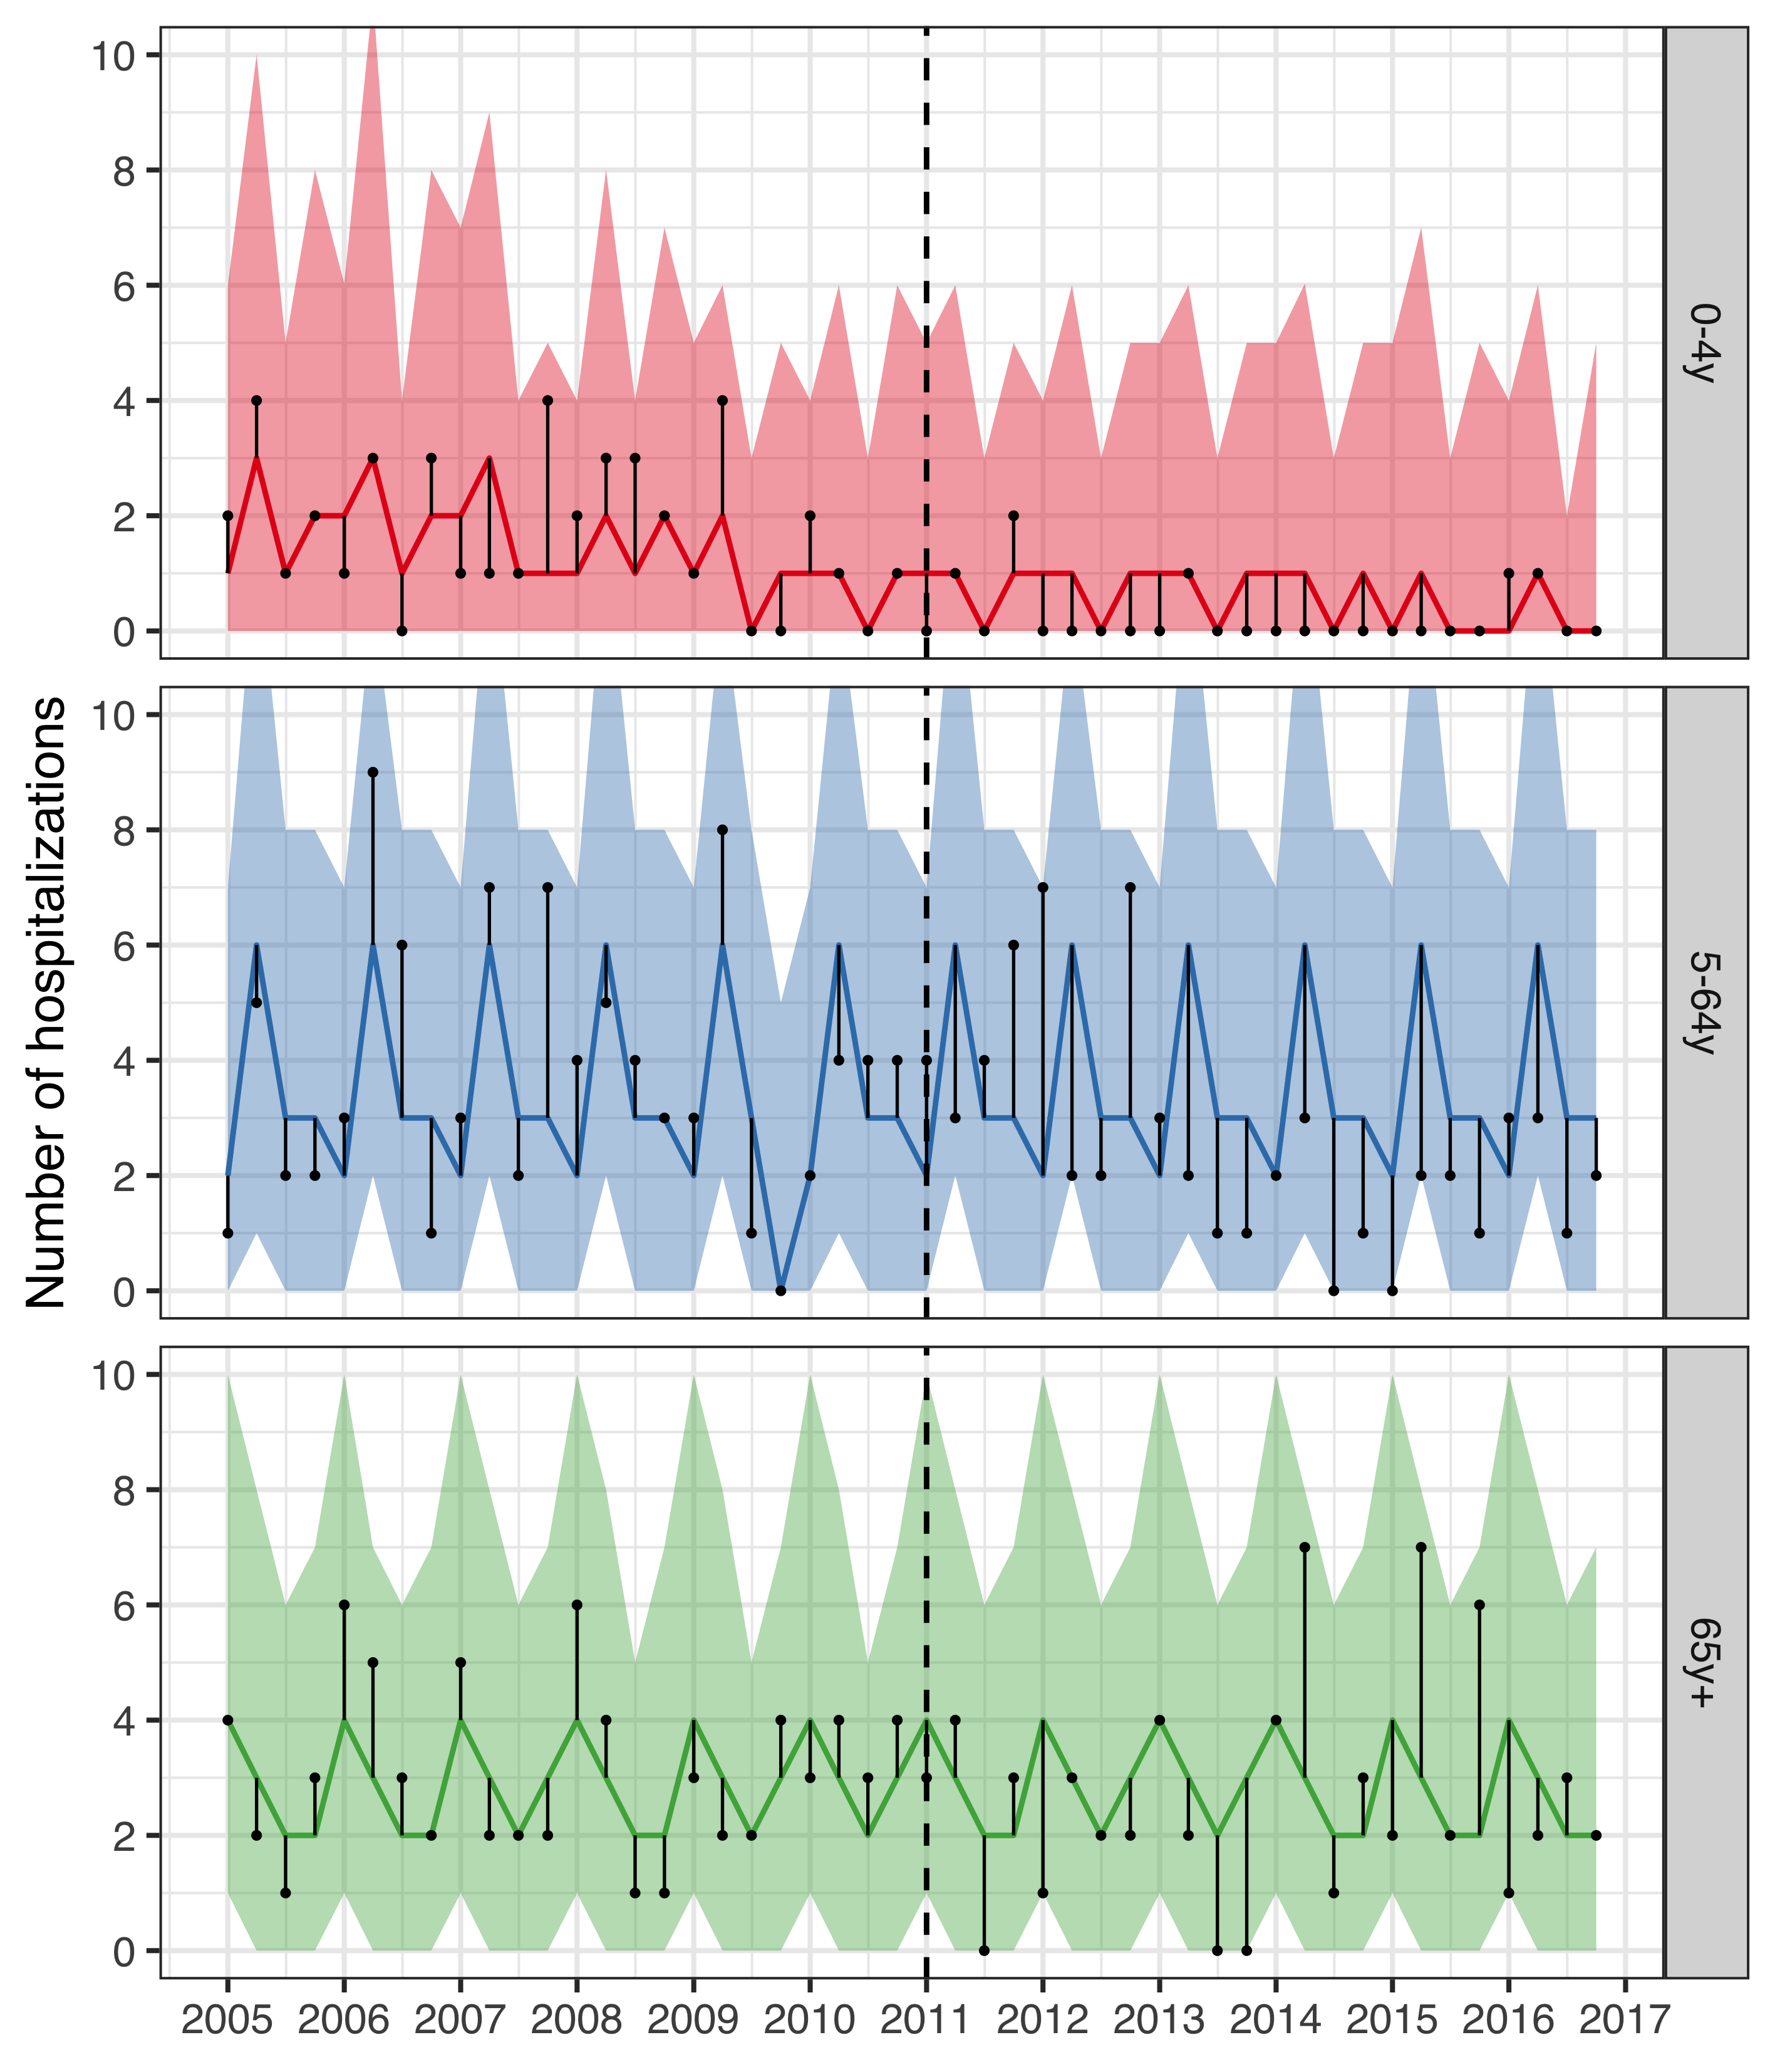

Figure 5 The observed and predicted number of IPD hospitalizations from 1 January 2005 to 31 December 2016 for each age-group. Observed cases are illustrated as black points, and the predicted number of cases are presented as lines with 95% credible intervals as a shaded area. The start of the vaccine period is delineated with a vertical black dotted line. The distance between the observed and predicted cases for each year-quarter is depicted with a thin black line. Assuming that the model is correct and no intervention had taken place, the black points would have an equal probability of occurring above and below the prediction line. Given that the majority of points are located below the prediction line, the figure suggests that the vaccine resulted in fewer IPD hospitalizations.

The rate ratios between the observed and predicted number of IPD hospitalizations in the post-vaccine period are shown in Table 5. The posterior median of the rate ratio for children younger than five years of age was 0.27, corresponding to a 50% probability that the vaccine impact was greater than or equal to 73%. The 95% credible intervals of the rate ratio were wide, reflecting the uncertainty due to the few number of IPD hospitalizations. However, 90% of the MCMC draws of the rate ratio were below 0.75 and 93% were under the threshold value of one. The 95% credible interval of the rate ratio among individuals five to 64 years of age was lower than one, indicating a 97.5% or greater probability that the rate of IPD hospitalization decreased in this age-group following the introduction of PHiD-CV10.

The 12-month rolling rate ratio is presented in Panel A of Figure 6. The rolling rate ratio for children zero to four years of age was unstable due to numerical issues with both the numerator and the denominator. In some 12-month periods, no IPD hospitalizations were observed and the resulting rate ratio was zero regardless of the denominator. In other periods, 2.5% or more of the MCMC draws predicted zero IPD hospitalizations, which resulted in a 95% credible intervals of the rate ratio that extended towards infinity. These issues do not change the overall interpretation of the prediction line presented in Panel A of Figure 6.

Table 5 The rate ratio between observed and predicted number of hospital admissions for invasive pneumococcal disease (IPD) during the post-vaccine period (2013-2016) is presented along with 95% credible intervals (95% CI) for the three age-groups. The predicted cumulative number of prevented cases as of 1 December 2016 is also presented. A negative number indicates that there is a non-zero probability that the vaccine caused more IPD hospitalizations to occur. Direct and indirect savings are presented in 2015 USD.

|  |  |  |  |  |
| --- | --- | --- | --- | --- |
| Age-group | Rate ratio (95% CI) | Cumulative cases prevented (95% CI) | Direct savings (95% CI) | Indirect savings (95% CI) |
| 0-4y | 0.27 (0.05-3.00) | 14 (-2 to 67) | 227,087$ (71,363$ to 618,919$) | 16,882$ (6,893$ to 38,718$) |
| 5-64y | 0.44 (0.31-0.68) | 29 (1 to 65) | 321,424$ (-455,573$ to 1,649,171$) | 12,983$ (-3,606$ to 33,498$) |
| 65y+ | 0.94 (0.62-1.53) | 10 (-16 to 45) | 73,395$ (-256,856$ to 516,864$) | 4,340$ (-10,903$ to 23,543$) |

The cumulative prevented IPD hospitalizations per age-group as of December 2016 are presented Table 5, and are shown as a function of time in Panel B of Figure 6. The posterior median of the cumulative prevented cases increases from the beginning of the post-vaccine period among children zero to four years of age.

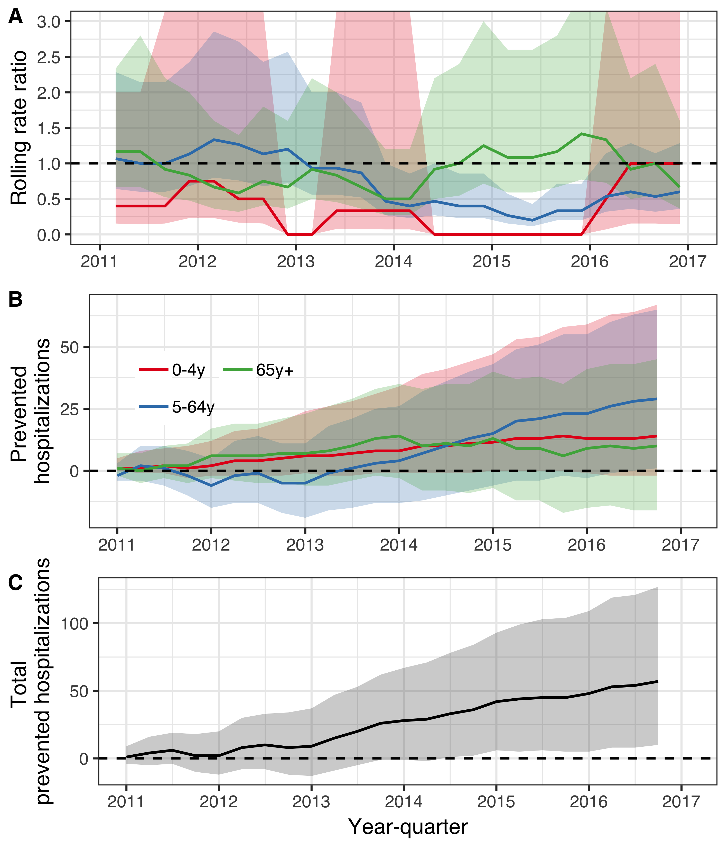

Figure 6 The population impact of the 10-valent *Haemophilus influenzae* protein D pneumococcal conjugate vaccine (PHiD-CV10) on hospital admissions for invasive pneumococcal disease is summarized. In Panel A, the estimated 12-month rolling rate ratio between the observed and predicted number of IPD hospitalizations in the post-vaccine period (2011-2016) is shown per age-group. Panel B depicts the cumulative number of prevented IPD hospitalizations during the post-vaccine period (2011-2015) for each age-group along with 95% credible intervals. The total cumulative prevented IPD hospitalizations regardless of age-group is shown in Panel C.

## Cost-effectiveness of PHiD-CV10

The total cost of introducing PHiD-CV10 into the Icelandic paediatric immunization programme from 1 January 2011 to 31 December 2017 was 3,451,805$ in constant 2015 USD. When direct cost-savings due to reductions in primary acre visits for AOM, and hospital admissions for pneumonia and invasive pneumococcal disease were included, the cost of the PHiD-CV10 introduction was -7,463,176$ (95% credible intervals -16,159,551$ to -582,135$) from the healthcare perspective as of 31 December 2015. This means that the immunization programme was cost-saving by 7,463,176$. Including days of work lost, the total cost of including PHiD-CV10 in the paediatric immunization programme from the societal perspective was -8,164,894$ (95% credible interval -17,197,959$ to -1,004,553$) as of 31 December 2015.

Given the observed distribution of costs associated with each AOM visit, the direct savings resulting from vaccine-prevented AOM visits was 1,389,900$ (95% credible interval 704,319$ to 2,201,925$). The vaccine introduction prevented 10,911 days of work lost due to AOM (95% credible interval 5,116 to 18,801), which translated to 194,152$ (95% credible interval 78,200$ to 364,155$) in productivity gains. The direct and indirect savings resulting from prevented AOM visits are shown in Table 3. Including only direct costs from averted visits and hospitalizations, the ICER was -543$ (95% credible interval -1,508$ to -48$) per prevented AOM case from the healthcare perspective. The corresponding ICER including indirect costs was -594$ (95% credible interval -1,597$ to -76$) per AOM case prevented.

The direct savings resulting from vaccine-prevented pneumonia hospitalizations was 13,330,902$ (95% credible interval 2,933,955$ to 26,270,332$), given the observed distribution of costs associated with each hospitalization, If the vaccine is assumed to have no other benefits than preventing pneumonia hospitalizations, and only the direct costs are considered, the ICER was -5,315$ (95% credible interval -8,877$ to 711$) per prevented pneumonia hospitalization, indicating a net savings of 5,315$ for each prevented hospitalization from the healthcare perspective. The immunization programme prevented 29,969 days of work lost (95% credible interval 9,964 to 52,900), which translated to 838,952$ (95% credible interval 273,559$ to 1,493,478$) in productivity gains. The direct and indirect savings resulting from prevented pneumonia hospitalizations are shown in Table 4. When cost-savings due to reductions in AOM visits or hospital admissions for IPD were also included,The ICER per prevented pneumonia hospitalization -5,640$ (95% credible interval -10,336$ to -1,032$) from the healthcare perspective as of 31 December 2015. Addtionally including loss of work resulted in an ICER of -7,440$ (95% credible interval -13,701$ to -1,175$).

The direct savings resulting from vaccine-prevented hospitalizations of IPD was 673,008$ (95% credible intervals -189,654$ to 2,081,594$). The vaccine introduction prevented 1,280 days of work lost (444 to 2,410) due to IPD, which translated to 35,280$ (95% credible intervals 9,437$ to 70,609$) in productivity gains. The direct and indirect savings resulting from prevented hospitalizations for IPD are shown in Table 4. When cost-savings due to reductions in AOM visits or hospital admissions for pneumonia were also included, the ICER was -119,992$ (95% credible interval -387,183$ to -9,542$) per prevented IPD hospitalization from the health care perspective. When days of work lost were also considered, the ICER was -130,791$ (95% credible interval -416,004$ to -15,860$) per prevented IPD hospitalization.

#Discussion

Landspitali University Hospital is the sole tertiary hospital in Iceland, and includes Children’s Hospital Iceland – Iceland’s only pediatric hospital. It provides primary and secondary care for the capital area, approximately 65% of the Icelandic population, and tertiary care for the whole population. In 2017, the total number of non-psychiatric curative care hospital beds in Iceland was 732 (www.statice.is). Of those, 669 (91%) were at Landspitali University Hospital.

#Supplementary filed

## Methods in detail

Four independent models that described the secular trend of pneumococcal infections were fitted. The simplest model was an interrupted time series (ITS) model without an offset term. Calender-month effects were accounted for using dummy variables. The ITS model used the pre-vaccine period to estimate the trend. It predicted the monthly number of cases of the disease category, assuming the pre-vaccine trend would have continued if the vaccination had not occurred. A second ITS model was estimated, which included an offset term of all non-respiratory visits. This model used the pre-vaccine period to estimate the relationship between the outcome of interest and all non-respiratory visits. It also predicted the occurrence of disease in the post-vaccine period by incorporating the observed number of non-respiratory visits, and assumed the relationship between the disease category and non-respiratory visits would not have changed, had the vaccination not occurred. The third model included synthetic controls as covariates and used Bayesian variable selection to choose which of them to include (Bruhn et al. 2017). The prior for each synthetic control was set as a Dirac spike with a point-mass at zero. The pre-vaccine period was used to estimate the relationship between the synthetic controls and the outcome of interest, and to select the optimal controls. This relationship was used to predict the trend in the post-vaccine period, had the vaccination not occurred. Finally, a two-step model was fitted, using a seasonal and trend decomposition (STL) and principal component analysis (PCA) (Shioda et al. 2018). STL was used to extract a smoothed trend for each of the synthetic controls. PCA was then used to extract the first principal component, which was used as a covariate in the final prediction model. Using data from the pre-vaccine period, leave-one-out cross-validation (LOOCV) was used to calibrate the models and calculate the average point-wise likelihood for each model, diagnostic category and age-group. The average point-wise likelihoods were used as weights in a Bayesian model-stacking procedure, to produce the final stacked model used in the analysis.

## Supplementary figures

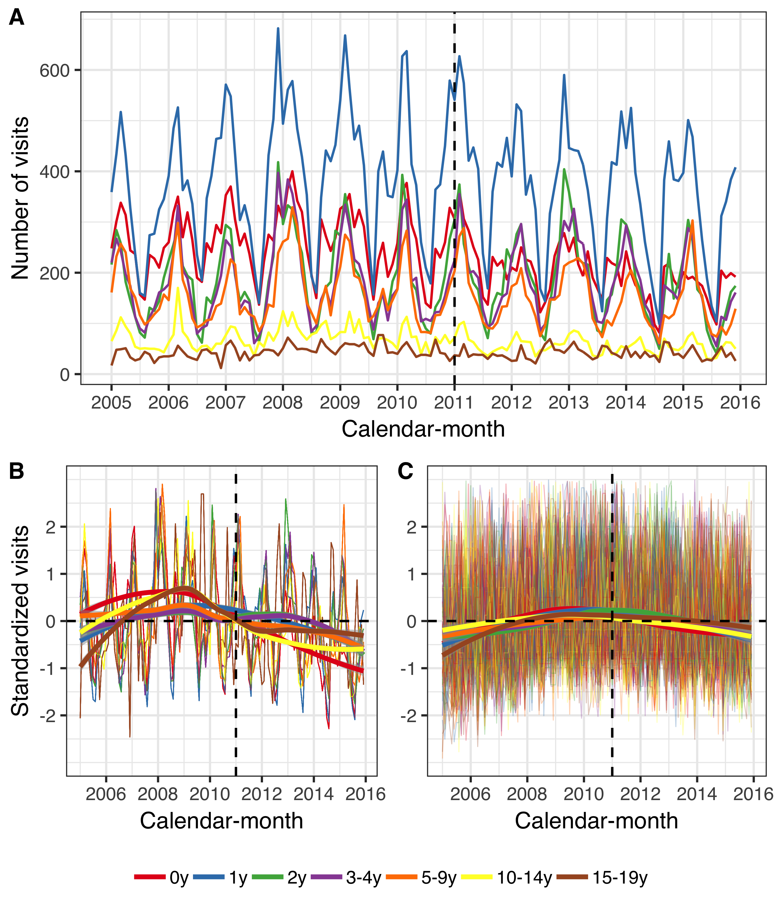

Figure 7 The figure presents the number of primary care visits among children younger than 20 years of age per calendar-month from 1 January 2005 to 31 December 2015. Children are divided into seven age-groups, listed in the figure legend. Panel A shows the monthly number of visits due to acute otitis media and its complications (AOM). Panels B and C, depict the standardized monthly number of AOM visits (Panel B) and all other visits (Panel C) per age-group. The Y-axis represents the number of standard deviations the observed visits are from from the mean of the entire period for each diagnosis and age-group. The horizontal dotted lines represent values that are zero standard deviations from the mean and the vertical dotted lines represent the beginning of the vaccine intervention. Locally estimated scatter-plot smoothing (LOESS) is used to produce an average trend. Panels B and C suggest that the number of both AOM visits and all other visits have decreased in the post-vaccine period, and that AOM visits have decreased to a larger degree.

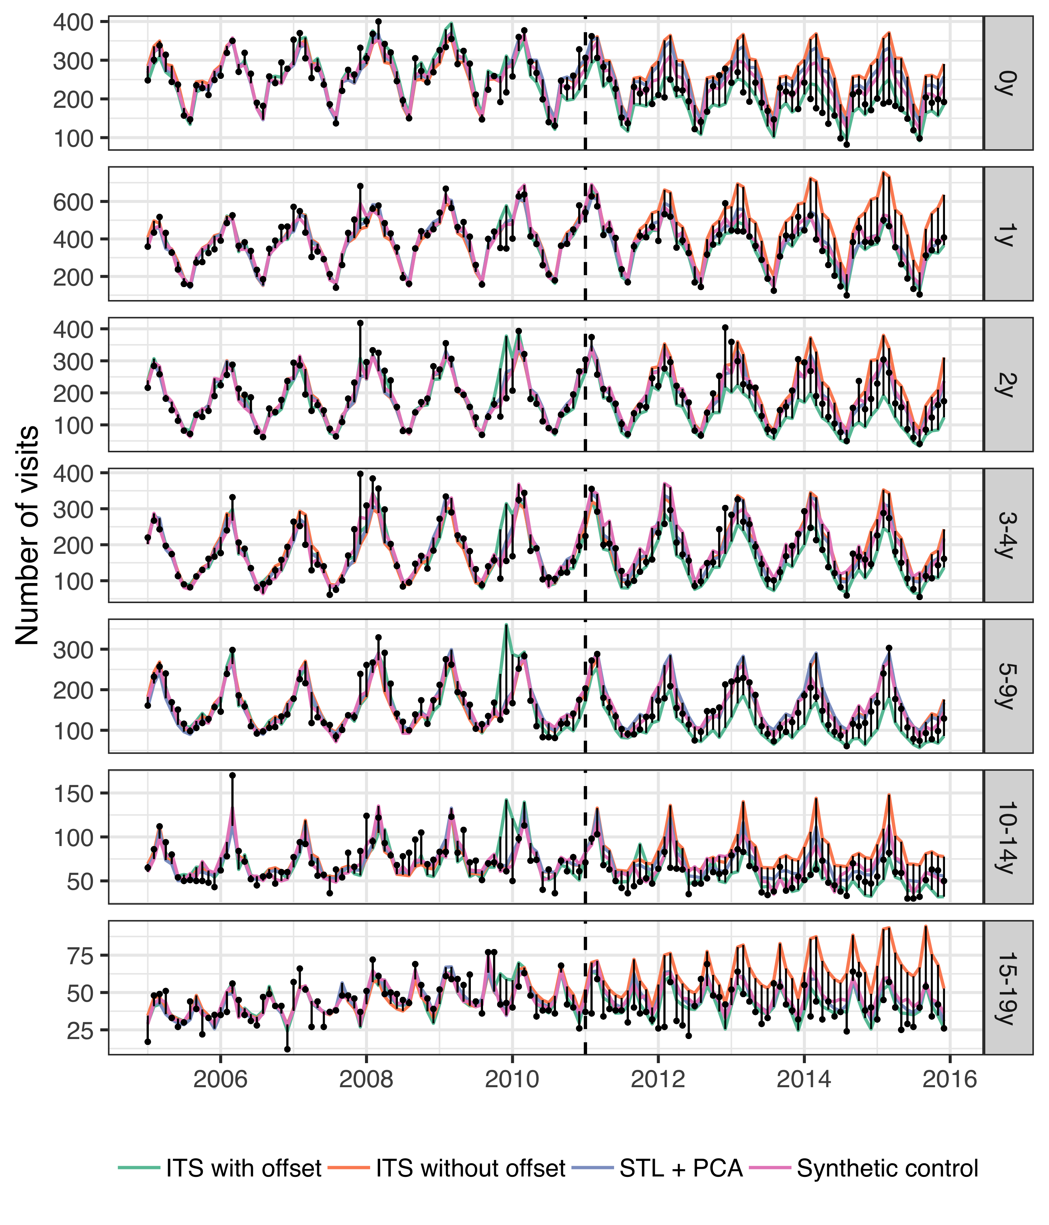

Figure 8 The observed and predicted number of visits for acute otitis media and its complications (AOM) from 1 January 2005 to 31 December 2015 for each age-group. Observed visits are illustrated as black points and the predicted number of visits are drawn as lines for each of the component models. The start of the vaccine period is delineated with a vertical black dotted line. Each component model was fitted to the observed visits in the pre-vaccine period, and then used to predict the number of visits in the post-vaccine period, had the vaccine not been introduced. The distance between the observed and predicted visits for each calendar-month is depicted with a thin black line. Longer distances suggest a larger discrepancy. Note that the scale of the Y-axis differ between age-groups.

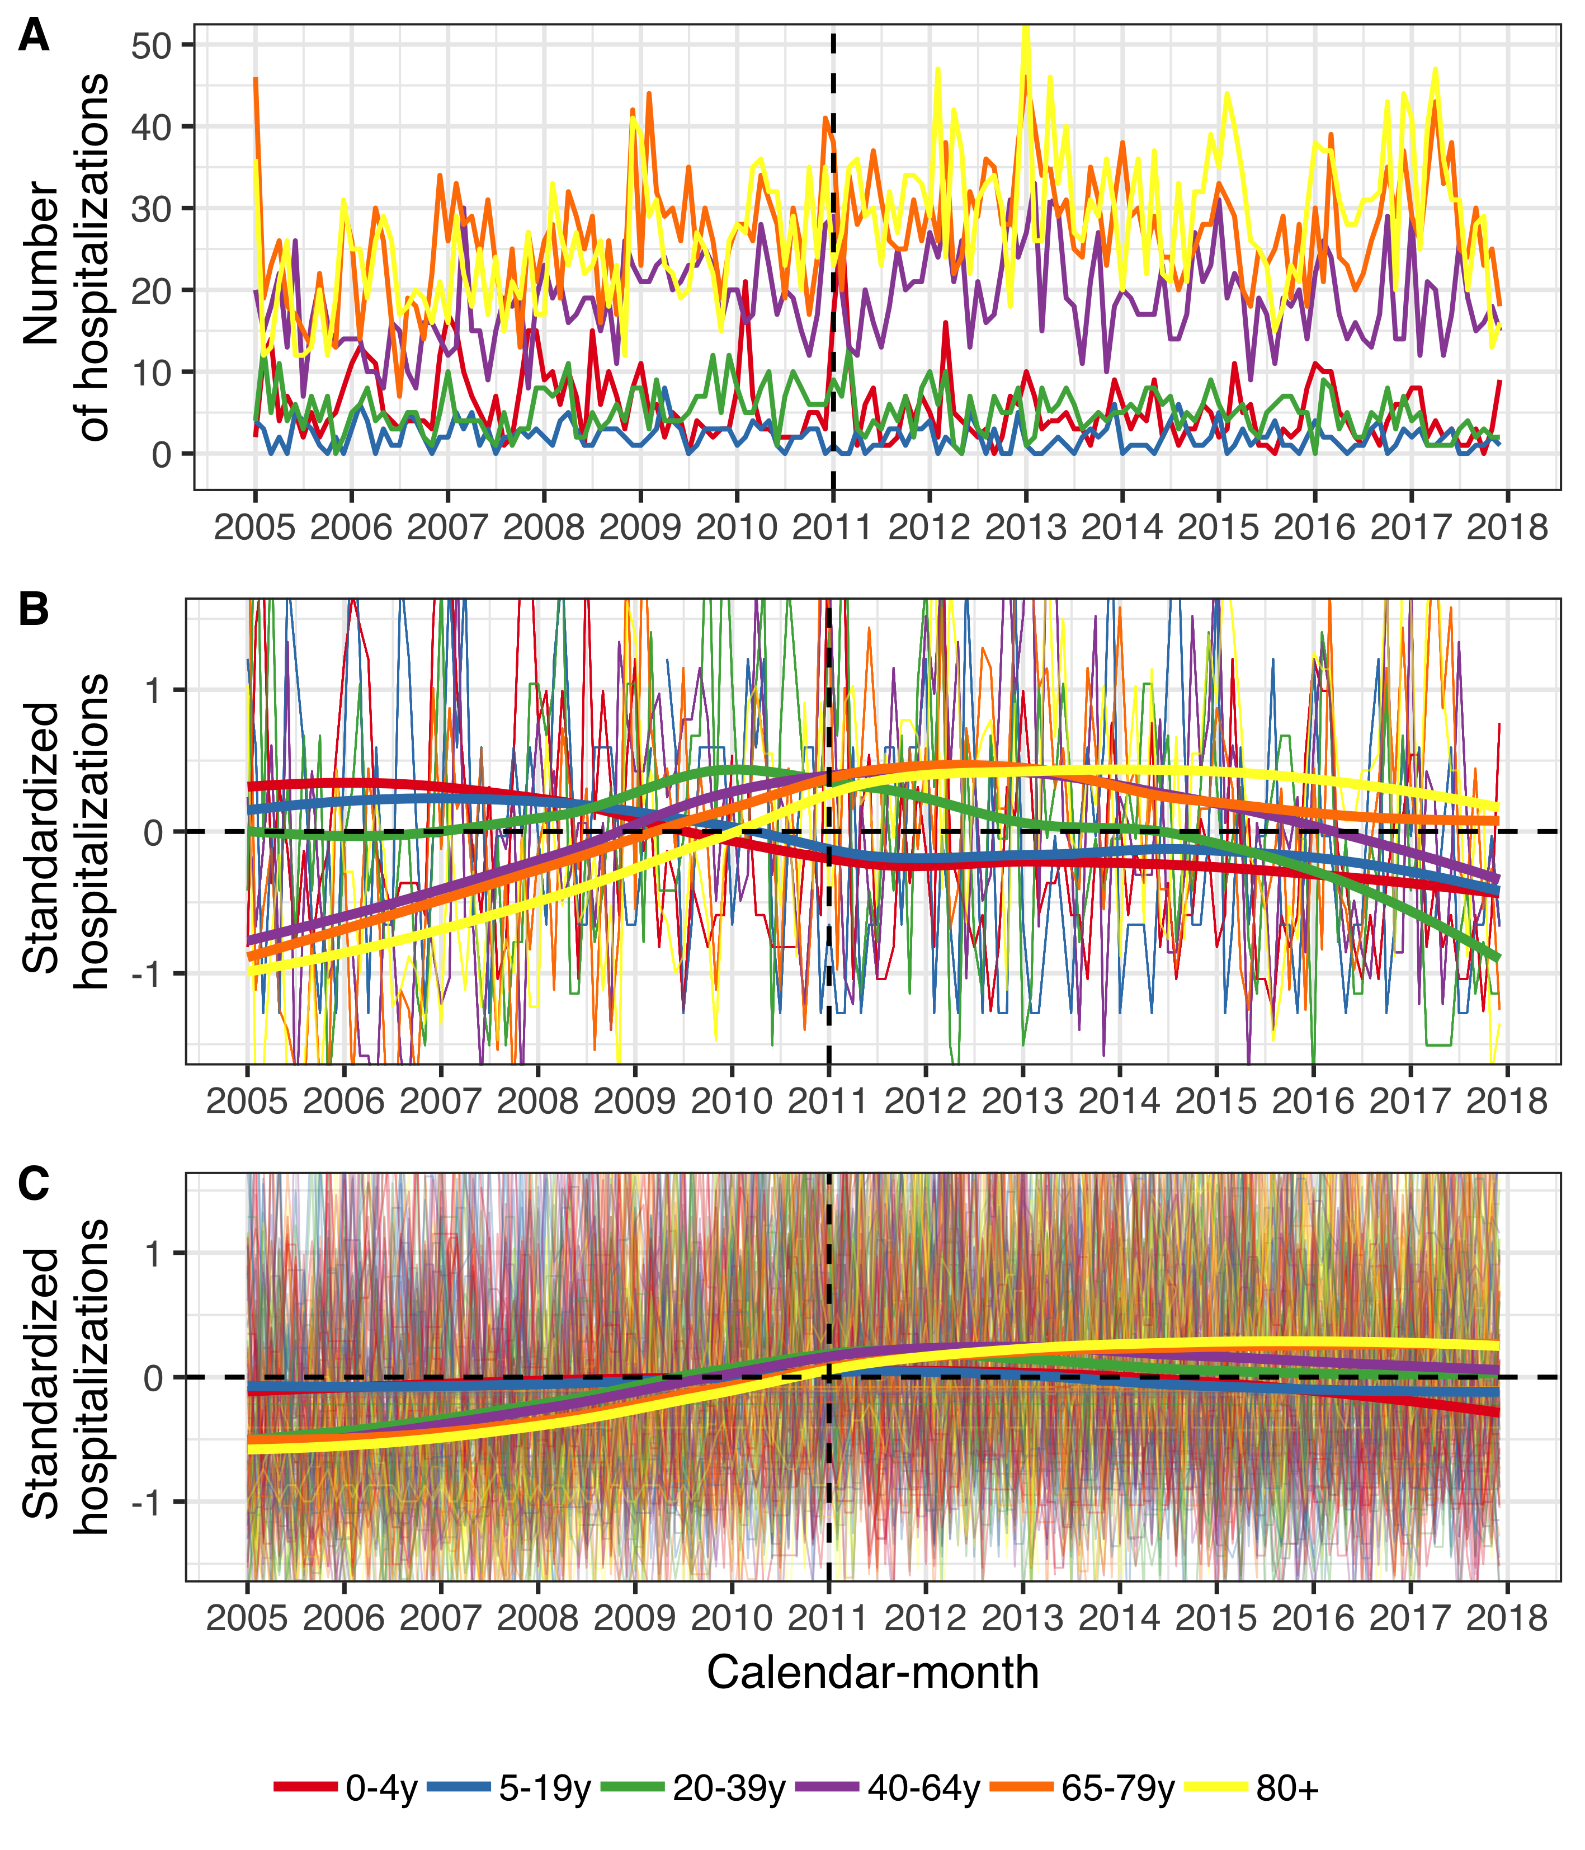

Figure 9 The figure presents the monthly number of hospital admissions for pneumonia and hospitalizations regardless of diagnosis from 1 January 2005 to 31 December 2017. Panel A shows the monthly number of pneumonia hospitalizations. Panels B and C depict the standardized monthly number of pneumonia hospitalizations (Panel B) and all other hospitaliations (Panel C) per age-group. The Y-axis shows how many standard deviations from the mean the observed hospitalizations are by diagnosis and age-group. The horizontal dotted lines represents values that are zero standard deviations from the mean and the vertical dotted lines represent the start of the vaccine intervention. Locally estimated scatter-plot smoothing (LOESS) is used to produce an average trend.

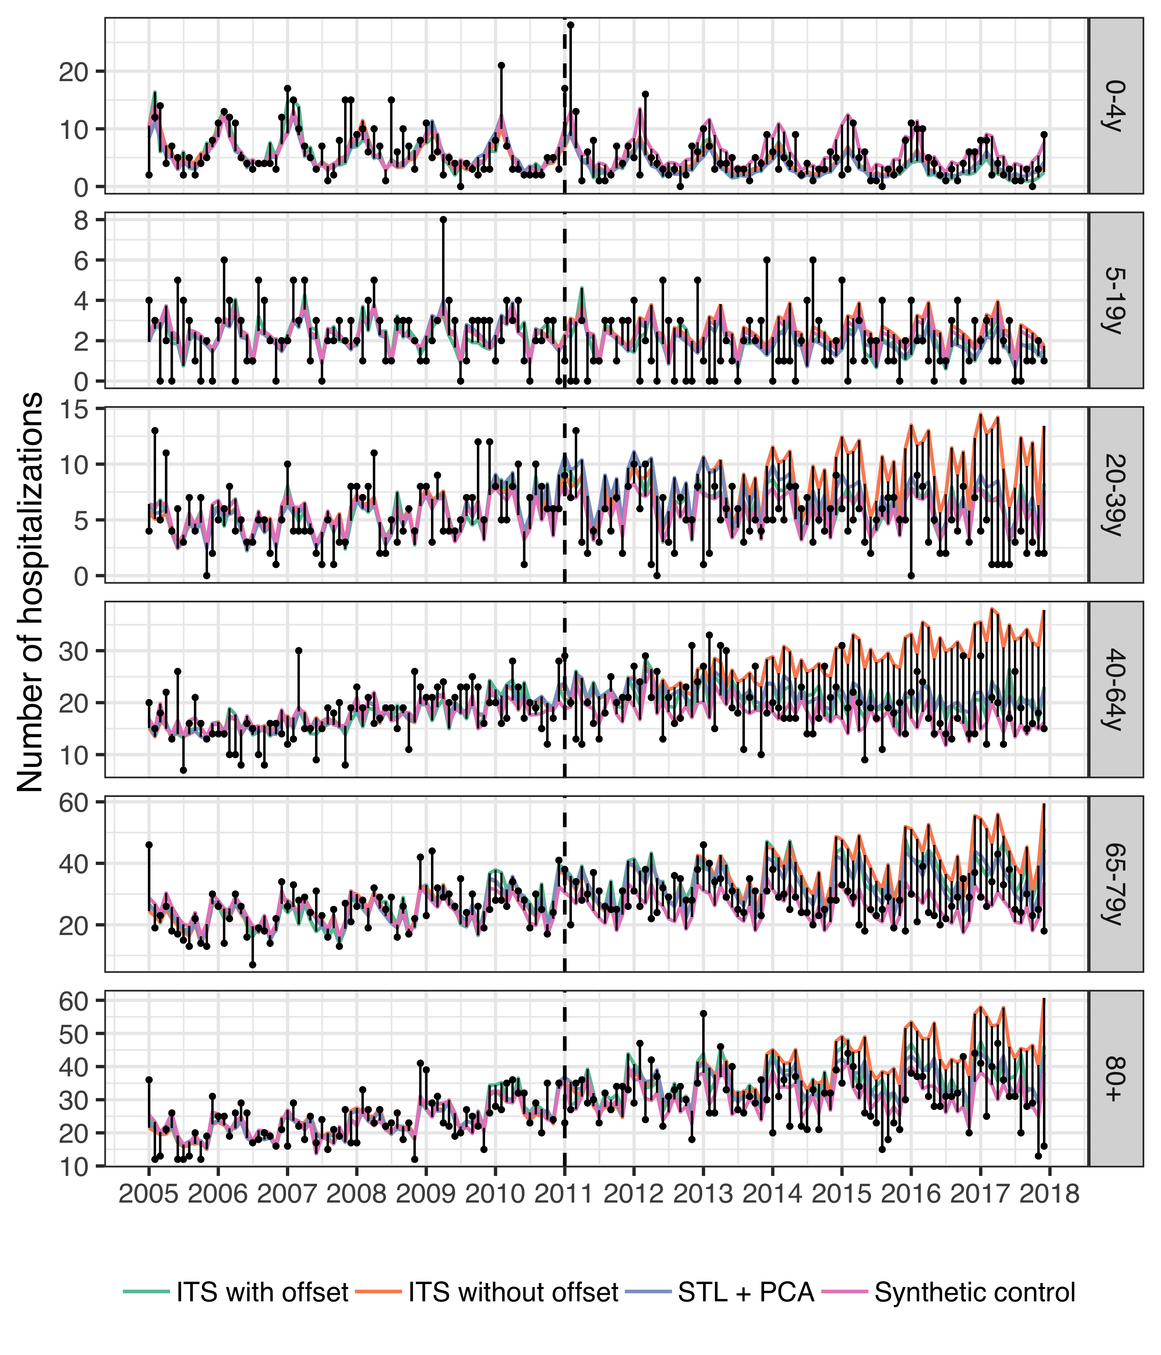

Figure 10 The observed and predicted number of pneumonia hospitalizations from 1 January 2005 to 31 December 2017 for each age-group. Observed cases are illustrated as black points and the predicted number of cases are drawn as lines for each of the component models. The start of the vaccine period is delineated with a vertical black dotted line. Each component model was fitted to the observed number of cases in the pre-vaccine period. They were then used to predict the number of cases that would have occurred in the post-vaccine period, had the vaccine not been introduced. The distance between the observed and predicted cases for each calendar-month is depicted with a thin black line. Longer distances suggest a larger discrepancy between observed and predicted cases. Note that the scale of the Y-axis differ between age-groups.

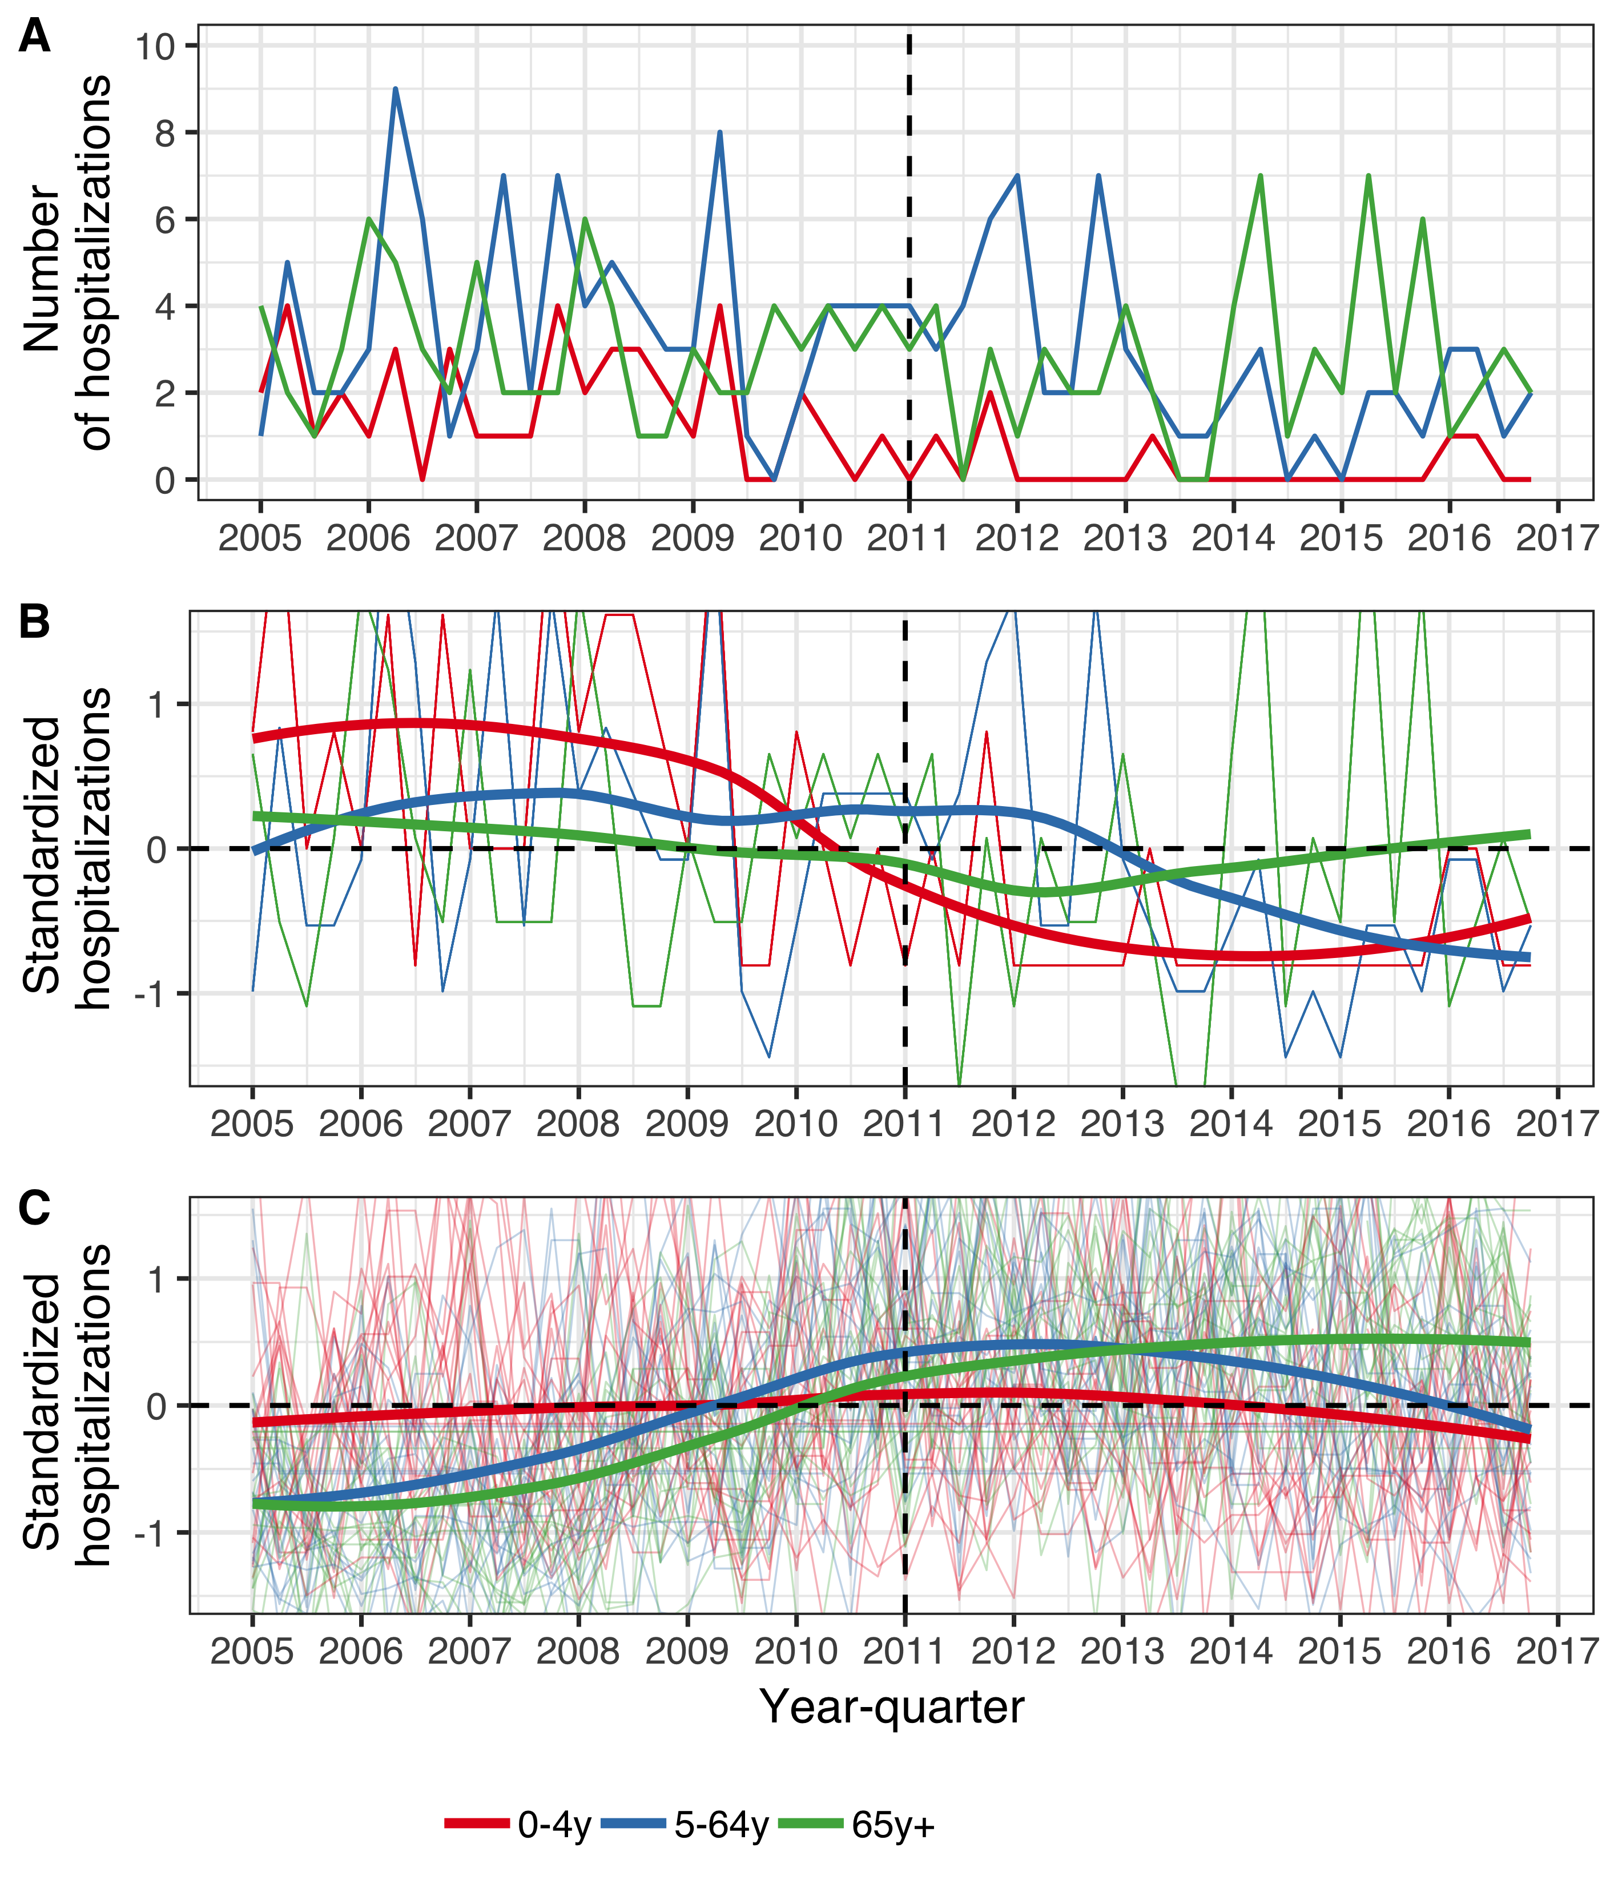

Figure 11 The figure presents the number of hospitalizations per year-quarter from 1 January 2005 to 31 December 2016. The population is divided into three age-groups, listed in the figure legend. Panel A shows the absolute quarterly number of hospital admissions due to invasive pneumococcal disease (IPD) regardless of serotype. Panels B and C, depict the standardized quarterly number of IPD hospitalizations (Panel B) and all-cause hospitalizations (Panel C) per age-group. The Y-axis represents the number of standard deviations from the mean hospitalizations for each quarter and each age-group. The horizontal dotted lines represent values that are zero standard deviations from the mean and the vertical dotted lines represent the start of the vaccine intervention. Locally estimated scatter-plot smoothing (LOESS) is used to produce an average trend. Panels B and C have been magnified to emphasize the interpretation of the trend line. Panels B and C show that standardized hospitalizations for IPD decreased in all age-groups, relative to the standardized hospitalizations regardless of cause.

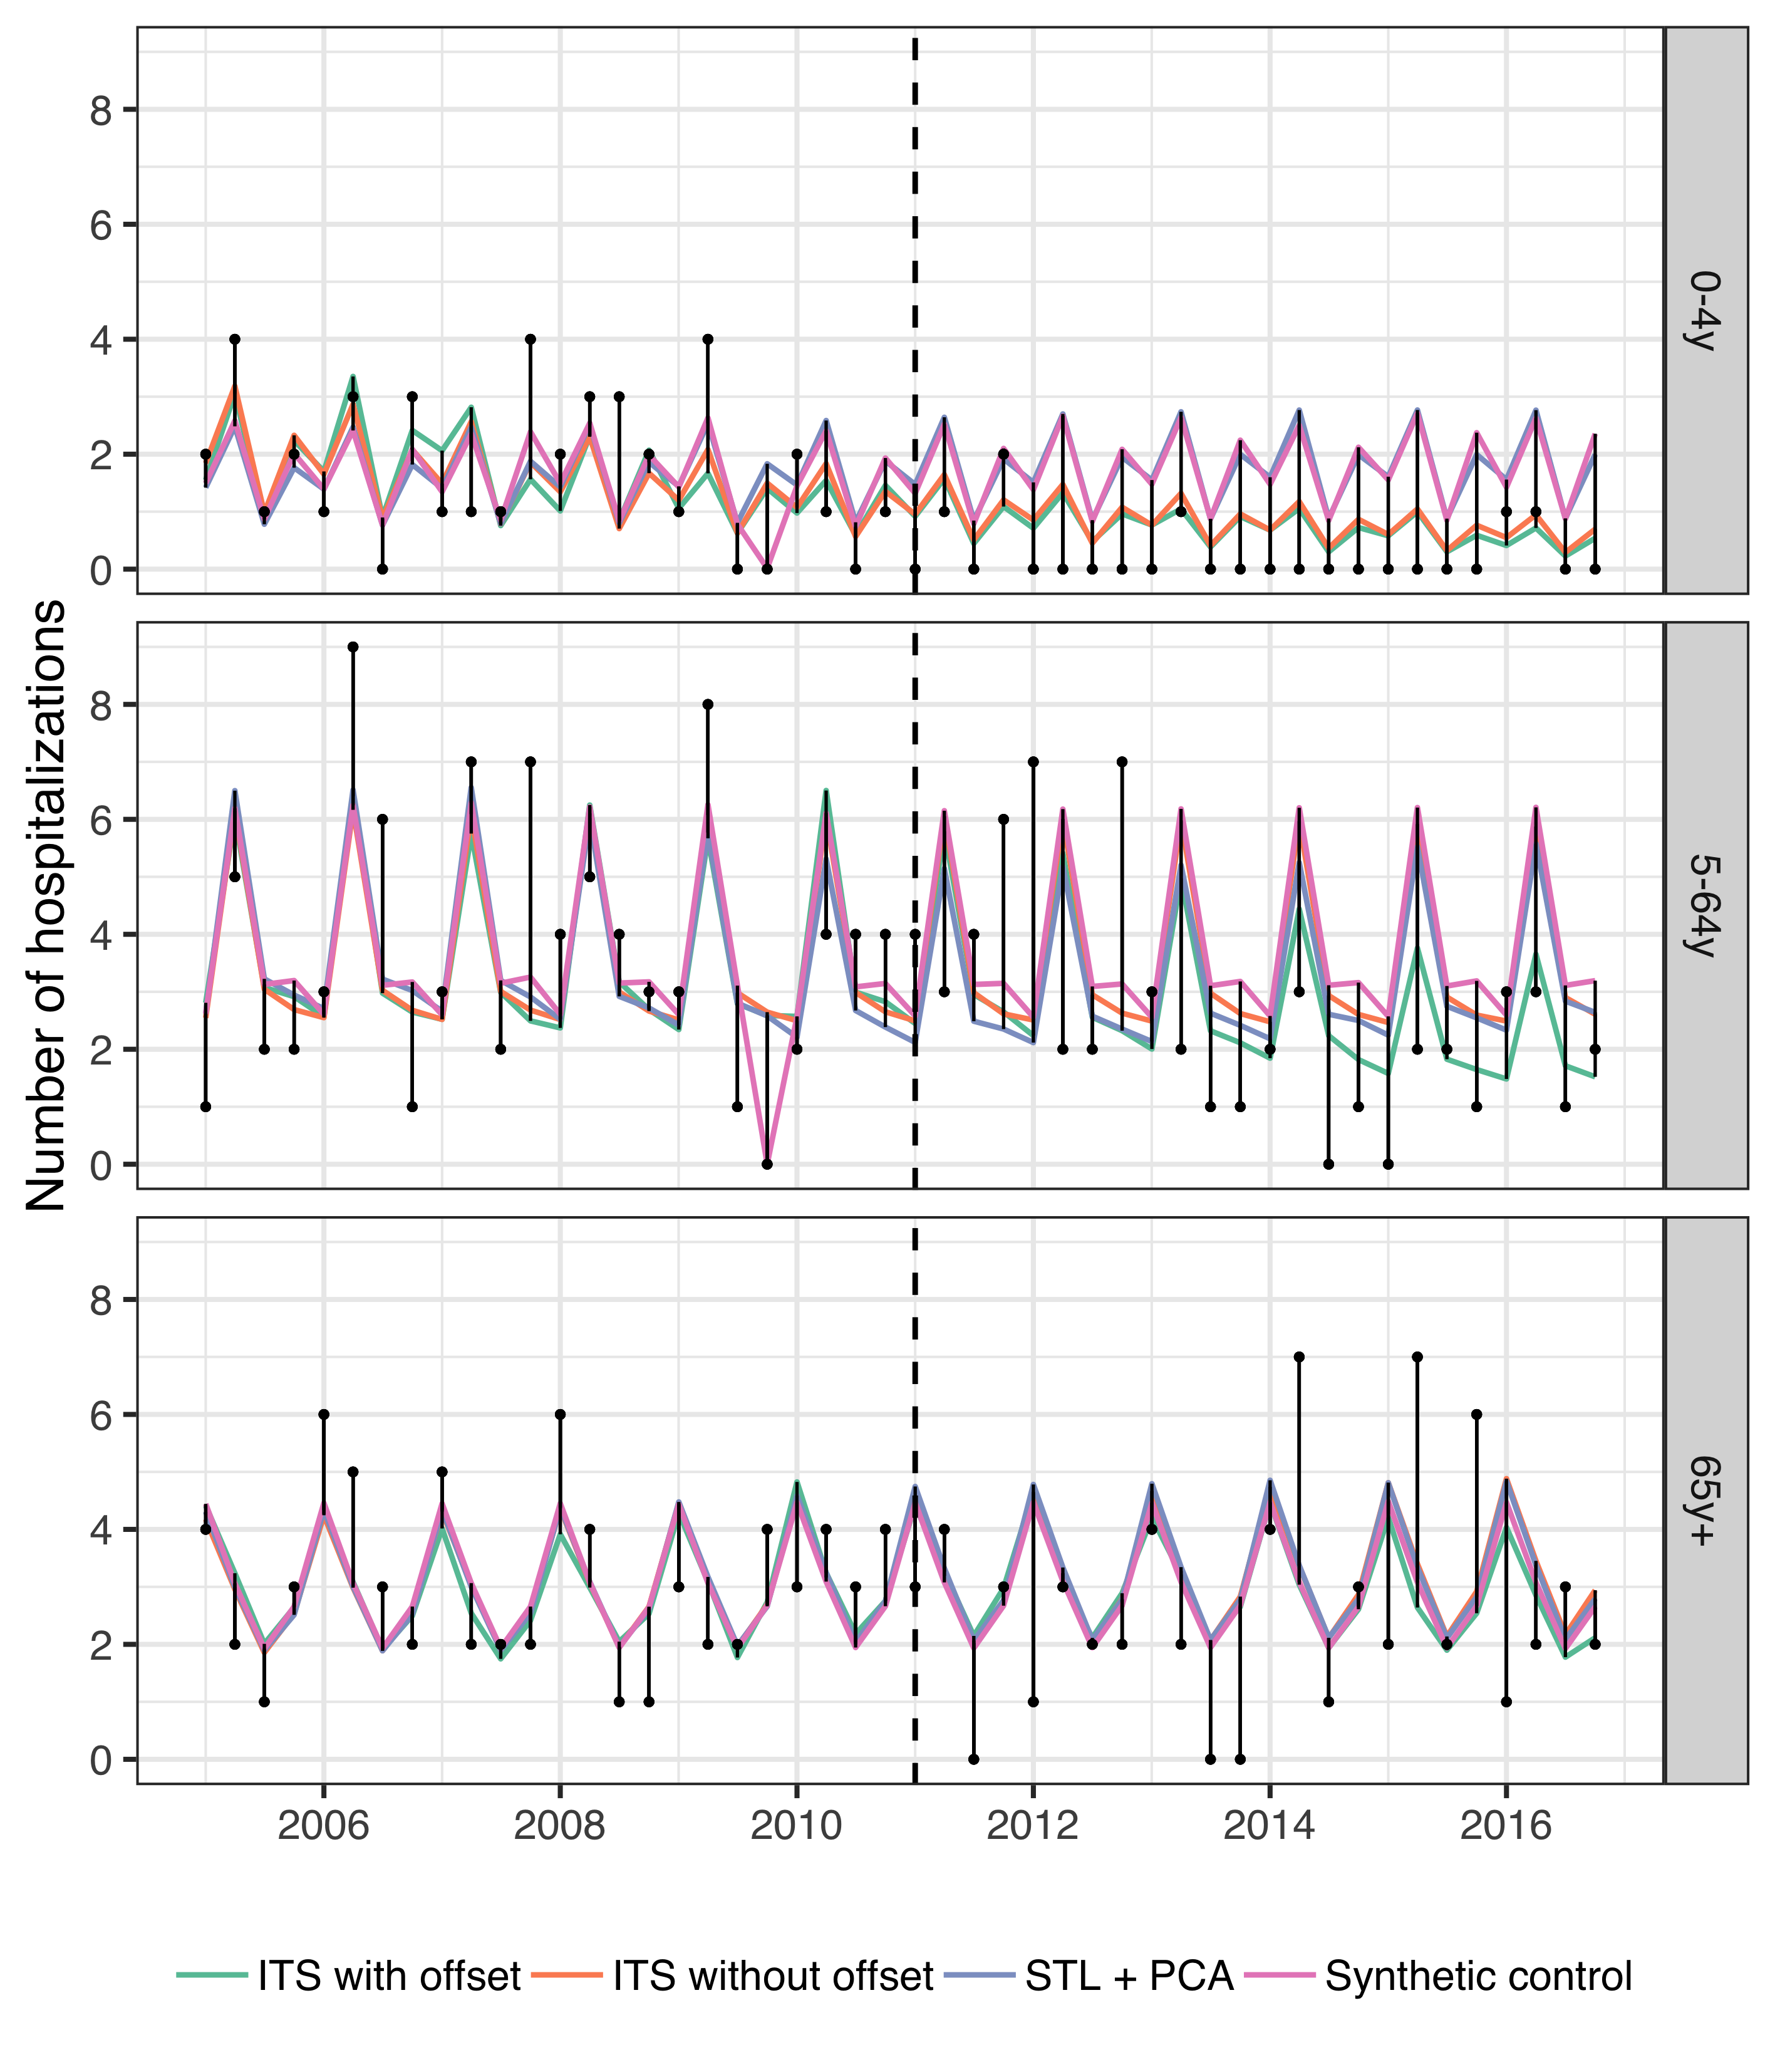

Figure 12 The observed and predicted number of IPD hospitalizations from 1 January 2005 to 31 December 2016 for each age-group. Observed cases are illustrated as black points and the predicted number of cases are drawn as lines for each of the component models. The start of the vaccine period is delineated with a vertical black dotted line. Each component model was fitted to the observed number of cases in the pre-vaccine period. They were then used to predict the number of cases that would have occurred in the post-vaccine period, had the vaccine not been introduced. The distance between the observed and predicted cases for each year-quarter is depicted with a thin black line. Longer distances suggest a larger discrepancy between observed and predicted cases.

## Supplementary tables

Table 6 The weights used to produce the final stacked model from the component models are presented. The weights for each component model were obtained by minimizing the leave-one-out mean squared error.

|  |  |  |  |  |  |
| --- | --- | --- | --- | --- | --- |
| Disease category | Age-group | Synthetic controls | ITS with offset | ITS without offset | STL + PCA |
| AOM visits | 0y | 0.221 | 0.000 | 0.121 | 0.659 |
| AOM visits | 1y | 0.149 | 0.000 | 0.610 | 0.241 |
| AOM visits | 2y | 0.000 | 0.000 | 0.479 | 0.521 |
| AOM visits | 3-4y | 0.661 | 0.000 | 0.339 | 0.000 |
| AOM visits | 5-9y | 0.726 | 0.000 | 0.274 | 0.000 |
| AOM visits | 10-14y | 1.000 | 0.000 | 0.000 | 0.000 |
| AOM visits | 15-19y | 0.018 | 0.000 | 0.078 | 0.904 |
| Pneumonia hospitalizations | 0-4y | 0.912 | 0.001 | 0.087 | 0.000 |
| Pneumonia hospitalizations | 5-19y | 1.000 | 0.000 | 0.000 | 0.000 |
| Pneumonia hospitalizations | 20-39y | 0.246 | 0.124 | 0.000 | 0.629 |
| Pneumonia hospitalizations | 40-64y | 0.241 | 0.000 | 0.000 | 0.759 |
| Pneumonia hospitalizations | 65-79y | 0.000 | 0.934 | 0.066 | 0.000 |
| Pneumonia hospitalizations | 80+ | 0.000 | 0.472 | 0.528 | 0.000 |
| IPD hospitalizations | 0-4y | 0.001 | 0.999 | 0.000 | 0.000 |
| IPD hospitalizations | 5-64y | 1.000 | 0.000 | 0.000 | 0.000 |
| IPD hospitalizations | 65y+ | 1.000 | 0.000 | 0.000 | 0.000 |

## Sensitivity analysis

Belgorodski, Natalia, Matthias Greiner, Kristin Tolksdorf, and Katharina Schueller. 2017. *RriskDistributions: Fitting Distributions to Given Data or Known Quantiles*. <https://CRAN.R-project.org/package=rriskDistributions>.

Ben-Shimol, Shalom, Noga Givon-Lavi, Eugene Leibovitz, Simon Raiz, David Greenberg, and Ron Dagan. 2014. “Near-Elimination of Otitis Media Caused by 13-Valent Pneumococcal Conjugate Vaccine (PCV) Serotypes in Southern Israel Shortly After Sequential Introduction of 7-Valent/13-Valent PCV.” *Clinical Infectious Diseases* 59 (12): 1724–32. <https://doi.org/10.1093/cid/ciu683>.

Black, S, H Shinefield, Bruce Fireman, E Lewis, P Ray, J R Hansen, L Elvin, et al. 2000. “Efficacy, safety and immunogenicity of heptavalent pneumococcal conjugate vaccine in children. Northern California Kaiser Permanente Vaccine Study Center Group.” *The Pediatric Infectious Disease Journal* 19 (3): 187–95. <http://www.ncbi.nlm.nih.gov/pubmed/10749457>.

Bruhn, Christian A W, Stephen Hetterich, Cynthia Schuck-Paim, Esra Kürüm, Robert J Taylor, Roger Lustig, Eugene D Shapiro, Joshua L Warren, Lone Simonsen, and Daniel M Weinberger. 2017. “Estimating the population-level impact of vaccines using synthetic controls.” *Proceedings of the National Academy of Sciences* 114 (7): 1524–9. <https://doi.org/10.1073/pnas.1612833114>.

Cutts, Felicity T, S M Zaman, Godwin C Enwere, S Jaffar, O S Levine, J B Okoko, C Oluwalana, et al. 2005. “Efficacy of nine-valent pneumococcal conjugate vaccine against pneumonia and invasive pneumococcal disease in The Gambia: randomised, double-blind, placebo-controlled trial.” *Lancet* 365 (9465): 1139–46. <https://doi.org/10.1016/s0140-6736(05)71876-6>.

Dvorzak, Michaela, and Helga Wagner. 2019. *Pogit: Bayesian Variable Selection for a Poisson-Logistic Model*. <https://CRAN.R-project.org/package=pogit>.

Eythorsson, Elias, Birgir Hrafnkelsson, Helga Erlendsdóttir, Sigmar Atli Gudmundsson, Karl G Kristinsson, and Ásgeir Haraldsson. 2017. “Decreased AOM with Treatment Failure Following Introduction of the Ten-Valent Pneumococcal Haemophilus influenzae Protein D Conjugate Vaccine.” *The Pediatric Infectious Disease Journal*, December, 1. <https://doi.org/10.1097/INF.0000000000001870>.

Holubar, Marisa, Maria Christina Stavroulakis, Yvonne Maldonado, John P A Ioannidis, and Despina Contopoulos-Ioannidis. 2017. “Impact of vaccine herd-protection effects in cost-effectiveness analyses of childhood vaccinations. A quantitative comparative analysis.” *PLoS ONE* 12 (3): 1–22. <https://doi.org/10.1371/journal.pone.0172414>.

Newall, A. T., J. F. Reyes, P. McIntyre, R. Menzies, P. Beutels, and J. G. Wood. 2016. “Retrospective economic evaluation of childhood 7-valent pneumococcal conjugate vaccination in Australia: Uncertain herd impact on pneumonia critical.” *Vaccine* 34 (3): 320–27. <https://doi.org/10.1016/j.vaccine.2015.11.053>.

*OECD Labour Force Statistics*. 2018. OECD Labour Force Statistics. OECD. <https://doi.org/10.1787/oecd_lfs-2018-en>.

Prymula, Roman, Pascal Peeters, Viktor Chrobok, Pavla Kriz, Elena Novakova, Eva Kaliskova, Igor Kohl, et al. 2006. “Pneumococcal capsular polysaccharides conjugated to protein D for prevention of acute otitis media caused by both Streptococcus pneumoniae and non-typable Haemophilus influenzae: A randomised double-blind efficacy study.” *Lancet* 367 (9512): 740–48. <https://doi.org/10.1016/S0140-6736(06)68304-9>.

Ray, G Thomas, Stephen I Pelton, Keith P Klugman, David R Strutton, and Matthew R Moore. 2009. “Cost-effectiveness of pneumococcal conjugate vaccine: An update after 7 years of use in the United States.” *Vaccine* 27 (47): 6483–94. <https://doi.org/10.1016/j.vaccine.2009.08.045>.

Shioda, Kayoko, Cynthia Schuck-Paim, Robert J. Taylor, Roger Lustig, Lone Simonsen, Joshua L Warren, and Daniel M Weinberger. 2018. “Challenges in estimating the impact of vaccination with sparse data.” *Epidemiology (Cambridge, Mass.)* 4 (5): 1. <https://doi.org/10.1097/EDE.0000000000000938>.

Shiri, Tinevimbo, Samik Datta, Jason Madan, Alexander Tsertsvadze, Pamela Royle, Matt J. Keeling, Noel D. McCarthy, and Stavros Petrou. 2017. “Indirect effects of childhood pneumococcal conjugate vaccination on invasive pneumococcal disease: a systematic review and meta-analysis.” *The Lancet Global Health* 5 (1): e51–e59. <https://doi.org/10.1016/S2214-109X(16)30306-0>.

Sigurdsson, Samuel, Elias Eythorsson, Birgir Hrafnkelsson, Helga Erlendsdóttir, Karl G Kristinsson, and Ásgeir Haraldsson. 2018. “Reduction in All-Cause Acute Otitis Media in Children <3 Years of Age in Primary Care Following Vaccination With 10-Valent Pneumococcal Haemophilus influenzae Protein-D Conjugate Vaccine: A Whole-Population Study.” *Clinical Infectious Diseases* 67 (8): 1213–9. <https://doi.org/10.1093/cid/ciy233>.

Tregnaghi, Miguel W. Marcelo, Xavier Sáez-Llorens, Pio López, Hector Abate, Enrique Smith, Adriana Pósleman, Arlene Calvo, et al. 2014. “Efficacy of pneumococcal nontypable Haemophilus influenzae protein D conjugate vaccine (PHiD-CV) in young Latin American children: A double-blind randomized controlled trial.” Edited by Elizabeth Miller. *PLoS Medicine* 11 (6): e1001657. <https://doi.org/10.1371/journal.pmed.1001657>.

Tsaban, Gal, and Shalom Ben-Shimol. 2017. “Indirect (herd) protection, following pneumococcal conjugated vaccines introduction: A systematic review of the literature.” *Vaccine* 35 (22): 2882–91. <https://doi.org/10.1016/j.vaccine.2017.04.032>.

Vooren, K van de, S Duranti, A Curto, and L Garattini. 2014. “Cost effectiveness of the new pneumococcal vaccines: a systematic review of European studies.” *Pharmacoeconomics* 32: 29–45. <https://doi.org/10.1007/s40273-013-0113-y>.